**CHAPTER 1**

**INTRODUCTION**

* **Project Aim and Objective**

The aim of the Indian Medicinal Plant Identification System (IMPIS) is to develop a reliable and efficient platform that leverages cutting-edge technologies to facilitate the rapid and accurate identification of medicinal plants native to India. By integrating machine learning and image processing techniques, IMPIS seeks to bridge the gap between traditional knowledge and modern technology, empowering researchers, practitioners, and conservationists in their efforts to study, conserve, and utilize medicinal plants for healthcare and biodiversity conservation purposes.

1. Develop a comprehensive database of Indian medicinal plants: Collect and curate a diverse dataset comprising high-resolution images and relevant information about medicinal plants, including their botanical characteristics, therapeutic properties, and traditional uses.
2. Implement advanced image processing techniques: Employ state-of-the-art image preprocessing techniques to enhance the quality of plant images, reduce noise, and standardize image features for improved identification accuracy.
3. Utilize machine learning algorithms: Train and optimize machine learning algorithms, such as convolutional neural networks (CNNs) and support vector machines (SVMs), to classify and identify medicinal plants based on extracted features from the image dataset.
4. Evaluate system performance: Conduct rigorous evaluation and validation of the IMPIS platform using real-world datasets to assess its accuracy, precision, recall, and F1-score in identifying medicinal plants across diverse species.
5. Enhance usability and accessibility: Design an intuitive user interface for IMPIS, making it accessible to a wide range of stakeholders, including researchers, healthcare professionals, traditional healers, and conservationists.
6. Promote interdisciplinary collaboration: Foster collaboration and knowledge sharing among botanists, pharmacologists, traditional medicine practitioners, technologists, and conservationists to maximize the impact and applicability of IMPIS in medicinal plant research, conservation, and healthcare practices

* **Problem Statement**

Traditional medicine systems in India, including Ayurveda, Siddha, and Unani, have a rich history deeply intertwined with the country's diverse flora. For centuries, these traditional systems have relied on the abundant medicinal plants found in India to treat a wide range of health conditions. However, despite the invaluable therapeutic properties of these plants, accurately identifying them remains a daunting task due to several inherent challenges.

India is blessed with a vast and diverse range of flora, comprising approximately 45,000 plant species. Among these, around 15,000 are known for their medicinal properties. Identifying and cataloging these plants manually is a time-consuming process that requires expertise in botany and traditional medicine systems. The sheer number and diversity of plant species make the task of identification arduous, with each plant possessing unique characteristics and properties. Furthermore, the taxonomic complexity of plant species adds another layer of difficulty to the identification process.

One of the major challenges in identifying medicinal plants lies in the morphological similarities among many species. While these plants may belong to different species, they often exhibit strikingly similar physical characteristics, such as leaf shape, flower color, and growth habit. This morphological similarity makes it challenging to distinguish between species, especially for individuals without specialized botanical knowledge. As a result, misidentification can occur, leading to erroneous therapeutic applications or conservation efforts. The risk of misidentification is particularly concerning in the context of traditional medicine, where the effectiveness of herbal remedies relies on the accurate identification of plant species.

Moreover, the rapid modernization of healthcare systems and changing socio-economic landscapes pose a threat to the preservation of traditional knowledge associated with medicinal plants. Traditional healers, who have been the custodians of this knowledge for generations, are dwindling in number. As younger generations pursue alternative career paths and urban lifestyles, there is a risk of losing valuable information about plant identification, uses, and conservation practices. The erosion of traditional knowledge not only undermines the cultural heritage of indigenous communities but also hampers efforts to conserve and sustainably utilize medicinal plant resources.

In addition to anthropogenic factors, habitat destruction and biodiversity loss pose significant threats to medicinal plant species in India. The rampant urbanization, industrialization, and agricultural expansion in the country have led to the degradation and loss of natural habitats. Forests, grasslands, and wetlands, which are home to many medicinal plant species, are being cleared at an alarming rate to make way for infrastructure development and agricultural expansion. Habitat destruction, coupled with unsustainable harvesting practices, poses a severe risk to biodiversity and the availability of medicinal plants for future generations.

Despite the critical importance of medicinal plants in traditional medicine systems and biodiversity conservation, there is a lack of comprehensive conservation strategies and initiatives in place. Existing efforts are often fragmented, underfunded, and poorly coordinated, leading to inadequate protection of medicinal plant species and their habitats. Conservation efforts are further hampered by the limited availability of data on medicinal plant populations, distribution patterns, and conservation status. Without robust conservation measures in place, many medicinal plant species face the threat of extinction, posing a significant loss to biodiversity and traditional healthcare practices.

Furthermore, limited access to reliable information about medicinal plants hampers research, conservation, and healthcare efforts. Researchers, practitioners, and policymakers often struggle to access accurate and up-to-date information about plant identification, therapeutic properties, and conservation status. This lack of information impedes efforts to conduct scientific research, develop evidence-based healthcare interventions, and formulate effective conservation strategies. Moreover, it perpetuates disparities in access to healthcare and exacerbates existing challenges in managing medicinal plant resources sustainably.

The need for sustainable utilization practices for medicinal plants is becoming increasingly urgent in the face of growing concerns about environmental sustainability and resource depletion. Achieving sustainability requires accurate identification, monitoring, and management of plant populations to ensure their long-term viability. However, existing identification systems are often inadequate, relying on manual methods that are time-consuming, labor-intensive, and prone to errors. As a result, there is a pressing need for the development and implementation of a robust, efficient, and accessible identification system like the Indian Medicinal Plant Identification System (IMPIS).

IMPIS aims to address the limitations of traditional methods by leveraging advanced technologies such as machine learning and image processing to facilitate rapid and accurate identification of medicinal plants. By providing researchers, practitioners, and policymakers with a reliable tool for plant identification and information retrieval, IMPIS has the potential to revolutionize medicinal plant research, conservation, and healthcare practices in India and beyond. It offers a comprehensive database of medicinal plants, complete with high-resolution images, botanical characteristics, therapeutic properties, and traditional uses. Moreover, it utilizes machine learning algorithms trained on large datasets to classify and identify medicinal plants based on extracted features from images.

In conclusion, the development and implementation of IMPIS represent a significant step forward in addressing the challenges associated with the identification, conservation, and sustainable utilization of medicinal plants in India. By leveraging advanced technologies and interdisciplinary approaches, IMPIS has the potential to empower stakeholders to make informed decisions and protect these invaluable resources for future generations. However, its success will depend on collaboration among diverse stakeholders, including researchers, practitioners, policymakers, and local communities, to ensure its effectiveness and sustainability in the long run.

* **Software Requirement**

The successful implementation of the Indian Medicinal Plant Identification System (IMPIS) relies on robust software requirements to support its functionality and performance. Here are the essential software requirements for IMPIS:

* + **Programming Language**: IMPIS will be developed using programming languages suitable for machine learning, image processing, and web application development. Popular choices include Python for its extensive libraries like TensorFlow and OpenCV, which are essential for machine learning and image processing tasks.
  + **Machine Learning Frameworks**: IMPIS requires machine learning frameworks to build, train, and deploy models for plant identification. TensorFlow, PyTorch, and scikit-learn are commonly used frameworks that offer tools for implementing various machine learning algorithms, including convolutional neural networks (CNNs) for image classification.
  + **Image Processing Libraries**: To preprocess and analyze images of medicinal plants, IMPIS relies on image processing libraries. OpenCV (Open Source Computer Vision Library) is a widely-used library that provides a plethora of tools and functions for image manipulation, feature extraction, and pattern recognition.
  + **Web Development Frameworks**: For developing the user interface and backend of IMPIS, web development frameworks are essential. Frameworks like Django and Flask (based on Python) or Node.js (JavaScript runtime) with Express.js are commonly used for building web applications due to their scalability, flexibility, and robustness.
  + **Database Management System (DBMS)**: A DBMS is needed to store and manage the vast amount of data associated with medicinal plants, including images, botanical information, and user data. PostgreSQL, MySQL, or MongoDB are popular choices for relational or NoSQL databases, offering features like scalability, data integrity, and query optimization.
  + **Cloud Services**: Cloud platforms such as Amazon Web Services (AWS), Google Cloud Platform (GCP), or Microsoft Azure provide infrastructure and services for hosting, deploying, and scaling web applications like IMPIS. These platforms offer storage, computing resources, and machine learning services that can enhance the performance and accessibility of the system.
  + **Version Control System**: To manage and collaborate on the development of IMPIS, a version control system is necessary. Git, with platforms like GitHub or GitLab, allows developers to track changes, coordinate work, and maintain code integrity throughout the development lifecycle.
  + **Integrated Development Environment (IDE)**: Developers working on IMPIS will utilize IDEs for writing, debugging, and testing code efficiently. Popular IDEs like PyCharm, Visual Studio Code, or Jupyter Notebook provide features such as code autocompletion, debugging tools, and project management capabilities.
* **Hardware Requirement**

The Indian Medicinal Plant Identification System (IMPIS) requires robust hardware components to support its computational tasks, image processing, and web application functionality. Here are the essential hardware requirements for IMPIS:

**Central Processing Unit (CPU):**

* A multi-core CPU with high clock speeds is essential for processing complex machine learning algorithms and image analysis tasks efficiently.
* Intel Core i7 or AMD Ryzen processors are suitable choices, providing sufficient computational power for training machine learning models and handling concurrent user requests.
* **Graphics Processing Unit (GPU):**
* A dedicated GPU accelerates the training of deep learning models and enhances the performance of image processing tasks.
* NVIDIA GeForce RTX or NVIDIA Quadro GPUs with CUDA support are recommended for their parallel processing capabilities and optimized performance for deep learning frameworks.

**Random Access Memory (RAM):**

* Sufficient RAM is necessary to handle large datasets, model training, and concurrent user requests.
* A minimum of 16 GB RAM is recommended for smooth operation, with higher capacities preferred for handling more extensive datasets and computational tasks.

**Storage:**

* Fast and ample storage is crucial for storing image datasets, model checkpoints, and application data.
* Solid State Drives (SSDs) offer faster read/write speeds compared to Hard Disk Drives (HDDs), improving the system's responsiveness and data access times.
* A minimum of 500 GB SSD storage is recommended for storing datasets and application files, with additional storage capacity for scalability.

**Network Interface:**

* A stable and high-speed network connection is necessary for accessing external datasets, cloud services, and deploying web applications.
* Gigabit Ethernet or Wi-Fi connectivity ensures reliable data transfer and seamless communication between the IMPIS server and external resources.

**Display Monitor:**

* A high-resolution display monitor is required for developers and administrators to interact with the IMPIS system during development, testing, and maintenance.
* A Full HD (1920x1080) or higher resolution monitor with good color accuracy is recommended for visualizing image data, debugging code, and monitoring system performance.

**Server Infrastructure:**

* For hosting the web application component of IMPIS, a dedicated server infrastructure is necessary.
* Cloud-based servers provided by platforms like Amazon Web Services (AWS), Google Cloud Platform (GCP), or Microsoft Azure offer scalability, reliability, and cost-effectiveness.
* Virtual Private Servers (VPS) or dedicated servers with sufficient computing resources, RAM, and storage capacity can also be used for hosting the IMPIS application.

**Backup and Redundancy:**

* Implementing backup and redundancy measures ensures data integrity and system availability in case of hardware failures or data loss.
* Regular backups of datasets, application code, and configuration files are essential for disaster recovery and continuity of operations.
* RAID (Redundant Array of Independent Disks) configurations or cloud-based backup solutions provide redundancy and data protection against hardware failures.

**CHAPTER 2**

**Literature Survey**

Medicinal plants have long been revered for their therapeutic properties and have played a central role in traditional medicine systems worldwide. In India, traditional medicine systems such as Ayurveda, Siddha, and Unani have extensively utilized medicinal plants for treating various ailments and promoting holistic well-being. However, the accurate identification of these plants poses significant challenges due to factors such as morphological similarities among species, loss of traditional knowledge, and habitat destruction. To address these challenges, researchers have turned to advancements in technology, particularly in the fields of machine learning, image processing, and artificial intelligence. The Indian Medicinal Plant Identification System (IMPIS) aims to leverage these technological innovations to develop a robust and efficient platform for the rapid and accurate identification of medicinal plants.

**Traditional Medicine Systems in India**: India boasts a rich heritage of traditional medicine systems, each with its unique principles, practices, and medicinal plant formulations. Ayurveda, one of the oldest systems of medicine, emphasizes the balance of mind, body, and spirit and relies heavily on medicinal plants for healing. Siddha medicine, practiced predominantly in South India, incorporates principles of Ayurveda and focuses on maintaining the equilibrium of bodily humors using natural remedies. Similarly, Unani medicine, influenced by ancient Greek and Persian traditions, employs a holistic approach to health and emphasizes the use of medicinal plants, minerals, and animal products. Collectively, these traditional medicine systems underscore the profound connection between nature and human health and highlight the importance of medicinal plants in promoting wellness.

**Challenges in Medicinal Plant Identification**: Despite their therapeutic significance, the accurate identification of medicinal plants presents several challenges. Morphological similarities among plant species, particularly within taxonomically complex families, make visual identification difficult, even for experts. Moreover, the loss of traditional knowledge associated with medicinal plants poses a significant barrier to accurate identification, as indigenous communities and traditional healers are dwindling in number. Habitat destruction, driven by urbanization, deforestation, and agricultural expansion, further exacerbates the challenge by threatening the survival of many medicinal plant species in their natural habitats. Inadequate conservation efforts and limited access to reliable information about medicinal plants compound these challenges, hindering research, conservation, and healthcare delivery efforts.

**Existing Identification Methods**: Various methods and technologies have been employed for medicinal plant identification, ranging from manual identification techniques to molecular methods and computer vision-based approaches. Manual identification methods, such as taxonomic keys and botanical descriptions, rely on the expertise of botanists and taxonomists but are time-consuming and require specialized knowledge. Molecular methods, including DNA barcoding and genetic sequencing, offer high accuracy but require laboratory facilities and expertise. In recent years, computer vision-based approaches, leveraging machine learning algorithms and image processing techniques, have emerged as promising solutions for automated plant identification. These approaches analyze botanical images to extract features and patterns, enabling the classification of plant species with high accuracy and efficiency.

**Advancements in Technology**: Advancements in technology, particularly in the fields of machine learning and image processing, have revolutionized medicinal plant research and identification. Machine learning algorithms, such as convolutional neural networks (CNNs), have demonstrated remarkable capabilities in image recognition and classification tasks. By training on large datasets of botanical images, these algorithms can learn to distinguish between different plant species based on their visual features. Image processing techniques, including feature extraction, texture analysis, and segmentation methods, further enhance the accuracy and efficiency of plant identification by extracting meaningful information from botanical images. Additionally, advancements in artificial intelligence, cloud computing, and mobile technology have made medicinal plant identification systems more accessible and scalable, facilitating their deployment in diverse settings.

**Machine Learning for Plant Identification**: Machine learning approaches, particularly deep learning models like CNNs, have shown great promise in automating the process of medicinal plant identification. These models learn to recognize complex patterns and features in botanical images, enabling them to classify plant species with high accuracy. Several studies have demonstrated the effectiveness of CNNs in tasks such as leaf recognition, species classification, and disease detection in plants. By leveraging large-scale datasets of botanical images, researchers have trained CNN models to identify medicinal plants based on their leaf morphology, flower characteristics, and overall appearance. These machine learning-based approaches offer a scalable and efficient solution for plant identification, paving the way for the development of IMPIS.

**Image Processing Techniques**: Image processing techniques play a crucial role in extracting relevant features and information from botanical images for plant identification. These techniques encompass a range of methods, including edge detection, color histogram analysis, texture analysis, and shape descriptors. Edge detection algorithms identify the boundaries and contours of plant parts, such as leaves and flowers, highlighting their distinctive features. Color histogram analysis quantifies the distribution of colors within an image, capturing unique color patterns characteristic of different plant species. Texture analysis methods analyze the surface characteristics of plant parts, such as leaf texture or flower morphology, to distinguish between species with similar appearances. Shape descriptors extract geometric features, such as size, shape, and symmetry, providing additional cues for species classification. By combining these image processing techniques, researchers can extract rich and informative features from botanical images, enabling accurate and efficient plant identification.

**Case Studies and Applications:** Several case studies and projects have demonstrated the practical applications of medicinal plant identification systems in real-world settings. For example, the Pl@ntNet project, a citizen science initiative, uses a mobile application to crowdsource botanical images and identify plant species using machine learning algorithms. Similarly, the LeafSnap application allows users to identify tree species by photographing their leaves and matching them against a database of botanical images. These projects showcase the potential of technology-driven approaches for democratizing plant identification and engaging citizen scientists in biodiversity conservation efforts. Additionally, academic research projects have developed specialized datasets, algorithms, and software tools for medicinal plant identification, demonstrating the feasibility and effectiveness of automated plant recognition systems.

**Challenges and Opportunities**: While technology-driven approaches offer promising solutions for medicinal plant identification, several challenges and opportunities remain. Data availability and quality pose significant challenges, as curated datasets of botanical images are often limited in size and scope. Additionally, model scalability, interpretability, and generalization are important considerations for deploying machine learning models in real-world applications. Ethical considerations, including data privacy, intellectual property rights, and cultural sensitivity, must be carefully addressed to ensure responsible and equitable use of medicinal plant identification systems. Despite these challenges, the rapid advancements in technology, coupled with interdisciplinary collaborations and community engagement, present unprecedented opportunities for developing IMPIS into a comprehensive and accessible platform for medicinal plant research, conservation, and healthcare practices.

**CHAPTER 3**

**PROJECT MANAGEMENT**

Project management has evolved from few simple principles to a wide subject with many complex concepts. To make it easier for people to understand project management, all PMBOK knowledge areas are classified into nine categories by PMBOK Guide. It is one of the most comprehensive model documents for project managers. In this article, we will take a deeper look at each of these knowledge areas to give you a better perspective of project management.

**1. Project Integration Management**

PMI defines project integration management as, “Processes and activities needed to identify, define, combine, unify and coordinate different processes and activities with project management process groups.” In short, project managers will have to keep an eye on every aspect of a project and check if everything is going according to the plan.

Good project integration is not possible without good teamwork. In order to be successful, you should have the resources who know their role and responsibilities. It is the responsibility of project managers to make project objectives clear and manage the inter-dependencies effectively to complete projects successfully. Therefore, project managers should focus on the bigger picture and follow a strategic approach to project management. Keep an eye on the obstacles and address them quickly before the problem gets out of hand.

**2. Project Scope Management**

Scope creep and lack of proper scope document is one of the main [reasons behind project failure](https://blog.taskque.com/causes-project-failure/). Furthermore, defining and documenting all the work comes under scope management. Project team should know what the deliverables are and what problems your project will solve. All this makes it easier for your team members to achieve the goals and helps clients in knowing what to expect from the projects. Therefore, project scope should also contain [milestones related to projects](https://blog.taskque.com/project-milestones-achieve/).

There are five sub-processes involved in the project scope management process.

* Collect requirements (Document stakeholder requirements)
* Define scope (Detailed description of project and what it will do)
* Create work breakdown structure (Dividing projects into smaller tasks)
* Verify scope (Getting acceptance of project deliverables from stakeholders)
* Control scope (Difference between actual and approved scope)

**3. Project Time Management**

One of the biggest challenges for project managers is to complete projects on time. However, most project managers do not understand this knowledge area. Hence, most projects under their supervision fail to complete before the deadline. There are six sub-processes associated with the project time management knowledge area that every project manager should know in order to complete projects on time.

Here are the six sub-processes:

* Define activities
* Sequence activities
* Estimate the resources required
* Estimate the time required
* Develop a schedule
* Control schedule

**4. Project Cost Management**

Most project managers consider managing costs against their project as their biggest challenge. However, cost management can be a difference maker between a successful project and a project failure. Many projects are abandoned due to budget constraints. If you do not want this to happen to your projects, then you should learn the art of effective project cost management and complete projects within the specified budgets. Latest tools and techniques can help you in this regard.

Here are three main sub-processes involved in project cost management.

* Estimate costs
* Determine budget
* Control costs

Make sure that you keep an eye on budget and expenditures so that you do not end up exceeding the budget. Unfortunately, most project managers do not pay attention to cost management from the beginning, spends a major chunk initially without any record and struggles to keep the project inside the budget later on. To keep project costs in check, you should track every dollar and where it is spent.

**5. Project Quality Management**

No matter how you define quality, a high-quality project is one which satisfies the customer needs and does not contain any defects and deficiencies. In order to achieve the highest project quality, project managers and their team should focus on customer requirements they have gathered initially, try to know what the customer wants and which problems your project will solve.

Develop a prototype of the project and give it to the end user to use it. Their feedback will allow you to make necessary adjustments before you deliver the final product to the customer. At the end of it all, the project should completely align with the user requirements in order to be called a high-quality project. Hence, all the requirements should be well documented so that your team can deliver a project that satisfies customer’s requirement.

**6. Project Human Resource Management**

Another knowledge area of project management that usually is ignored is project human resource management. It is the set of processes and activities involved in organizing, leading and managing project teams. It is how you manage the most valuable asset of your company i.e. people. To be successful at it, project managers should have a clear strategy when it comes to hiring and staffing people and inducting them into project teams. Hiring the right people can increase the chances of your success.

Project Human Resource Management process involves following sub-processes:

* Developing a human resource plan
* Hire the project team
* Develop a project team
* Manage project team

**7. Project Communication Management**

Poor project communications can wreck havoc on your project progress. Moreover, it can take your project towards failure. So, if you want to complete projects successfully, all team members should be on the same page. Moreover, they should work as a team to achieve the common objective. If you want that to happen, then you will have to communicate effectively and regularly. Project managers can enhance collaboration and communication among their team members by using [task management software](https://taskque.com/) that offers communications and collaboration features. Here are some of the key activities that project managers need to undertake to ensure uninterrupted communications throughout the project:

* Identify stakeholders
* Plan communications
* Distribute information
* Manage stakeholder expectations
* Report performance

**8. Project Risk Management**

Most project managers consider risk management as the most important factor in completing projects successfully. Therefore, effective risk management plays an important role in preventing your projects from failure. In addition to this, project managers can reduce the risk by following a proactive approach and managing risks at the initial stage. Project managers who ignore minor risks have to suffer from project failure because these minor risks can turn into major risk and can lead to a project disaster if left unattended. Here are some of the activities that project managers will have to undertake in project risk management:

* Plan risk management
* Identify risks
* Perform qualitative and quantitative risk analysis
* Plan risk response
* Monitor and control risks

**9. Project Procurement Management**

The Project Procurement Management knowledge area covers all the aspects related to purchase and acquiring of products and services needed to complete projects effectively. Although, the procurement process is quite transparent and conducted through a contract or agreement, it important for project managers to ensure that there are no discrepancies. Whether you are a buyer or seller, you need to understand both perspectives to get a better knowledge of the project procurement process. Additionally, cost benefit analysis, cost utility analysis, and risk analysis also comes under project procurement management.

* Plan procurement
* Conduct procurement
* Administer procurement
* Close procurement

**10. Project Management Tools:**

Project management required tools to manage the work , time and resources. At present many of the software are available for project management. Some of the popular software tools are as follows.

### 01. [Trello](http://send.getapp.com/aff_c?offer_id=677&aff_id=1371)

Trello is an project management tool, instead this app is a free visual way to to glance at the entire project with a single view. With Trello you can organise cards, these cards can be your thoughts, conversations and to-do lists and be placed on a board for everyone to collaborate on.

### 02. [Basecamp](http://send.getapp.com/aff_c?offer_id=637&aff_id=1371)

Basecamp is the granddaddy of project management apps. Basecamp is considered the leading project management tool around. It boost a simple and easy to use interface to collaborate with your team and client. It allows you to create multiple projects and setup discussions, write to-do lists, manage files, create and share documents, and organise dates for scheduling.

### 03. [Teamwork Projects](http://send.getapp.com/aff_c?offer_id=947&aff_id=1371)

Teamwork Projects is the ultimate productivity tool to manage projects with your team. Teamwork allows you to keep all your projects, tasks and files all in one place and easily collaborate with a team. Teamwork helps you to visualise the entire project through a marked calendar and gantt chart and setup reporting. Teamwork supports file management with Google Drive, Box.com and Dropbox. As well as integration with leading apps such as third party accounting software and customer support apps.

### 04. [Resource Guru](https://resourceguruapp.com/)

Billed as the "simple way to schedule people, equipment and other resources", Resource Guru is a streamlined resource scheduling and leave management tool that’s designed to keep your projects on track. You can plan your team's workloads, receive daily booking reminders, report on KPIs, and more. Apple, Saatchi & Saatchi and Deloitte are among some of the cloud-based team calendar’s heavyweight customers.

### 05. [ActiveCollab](http://send.getapp.com/aff_c?offer_id=949&aff_id=1371)

ActiveCollab recently released its new version 5.0. The new revamped app is now more powerful and focused project management tool. It offers team collaborating features, task management, time tracking and importing expenses. One of the biggest asset of ActiveCollab is it offers invoicing features. You are able to track payments and expenses and have invoices paid directly within ActiveCollab with PayPal, and other credit card payments.

### 06. [Zoho Projects](http://send.appdoubler.com/aff_c?offer_id=101&aff_id=1371)

Zoho offers a wide range of business software including Projects. Zoho Projects is an proficient tool to project plan and project coordinator from start to finish. It boost all the features you need for project management with some advance features including reporting, integration with Google Apps and Dropbox, bug tracking, setup Wiki Pages to build a repository of information, forums and more.

### 07. [Jira](http://send.getapp.com/aff_c?offer_id=281&aff_id=1371)

Jira is specifically targeted for software development teams. Jira offers abilities to raise issues and bugs. Jira makes it real easy to track bugs and see which issues are still outstanding and how much time was spent on each task. Jira offer other products including Confluence a document collaboration tool, and HipChat a team chat and video and file sharing platform and other products.

### 08. [Asana](http://send.getapp.com/aff_c?offer_id=587&aff_id=1371)

Asana is the easiest way for teams to track their work so everyone knows who's doing what, by when. With tasks, projects, conversations and dashboards, Asana keeps your work organized, and teammates accountable so you can move work forward faster. Asana also lets you keep track of your work wherever you are with mobile apps for both iOS and Android.

### 09. [Podio](http://send.getapp.com/aff_c?offer_id=951&aff_id=1371)

Podio is a ever growing tool to organise and communication tool for any business. Podio allows you to personalise this platform to fit your business needs. Besides being able to communicate with a team, setup task management, use as a file storage system, like a traditional project management app, Podio can be an internal intranet for all your colleagues and departments to interact.

### 10. [Freedcamp](https://freedcamp.com/)

Whatever your project may be, either setting up an event, a web project or organising a wedding, Freedcamp helps you organise and plan effectively. Freedcamp has an organised dashboard to view the entire project at a glance. You can easily setup tasks, use sticky notes to visually setup tasks and organise them into the calendar. Freedcamp provides advance add-ons for high level business use including CRM, invoicing, issue tracking and setting up wiki pages.

### 11. [Wrike](http://send.getapp.com/aff_c?offer_id=239&aff_id=1371)

Wrike is advance application to help you work smarter. By making sure you are always staying on track and ensure you have the adequate resources to finish on time and on budget.Setting up tasks, engage your team and integrate with your business tools including Google Apps, Microsoft Excel, Dropbox and many more is so easy with Wrike.

**CHAPTER 4**

**Technology Applied**

* **Agile project management and Scrum**

Agile project management and Scrum methodologies have become increasingly popular in recent years, offering adaptable approaches to handling complex projects like the development of the Indian Medicinal Plant Identification System (IMPIS). These methodologies prioritize iterative progress, constant collaboration, and quick response to changes, making them ideal for dynamic projects in technology and innovation.

For IMPIS, Agile principles were crucial in guiding the team through every stage of development, starting from the project's inception to its final deployment. The iterative nature of Agile allowed the team to break down the project into smaller, manageable tasks or "sprints," each focused on delivering specific features or functionalities. This approach made it easier for stakeholders to provide feedback and adjust requirements based on evolving priorities and user needs.

A key aspect of Agile project management is the emphasis on self-organizing, cross-functional teams. In the case of IMPIS, a diverse team consisting of botanists, data scientists, software engineers, and domain experts collaborated closely throughout the project. This collaborative environment promoted creativity, teamwork, and collective ownership of project objectives.

Within the Agile framework, Scrum provided a structured approach to organizing and managing the project's iterative cycles. The Scrum framework defines clear roles, ceremonies, and artifacts aimed at improving communication, transparency, and productivity.

For instance, the Scrum team included three primary roles: the Product Owner, responsible for defining project requirements; the Scrum Master, tasked with facilitating team collaboration; and the Development Team, responsible for implementing project deliverables.

During each sprint, the team conducted sprint planning meetings to outline the sprint's objectives and tasks. These meetings ensured that everyone was aligned on what needed to be accomplished and allowed for adjustments based on team capacity and priorities.

Daily stand-up meetings, or "daily scrums," provided a forum for team members to discuss progress, challenges, and any necessary adjustments to the plan. These brief, focused meetings promoted transparency, accountability, and collaboration among team members.

At the end of each sprint, the team held sprint review and retrospective meetings to evaluate progress, gather feedback, and identify areas for improvement. This reflection and adaptation process helped the team continuously refine their approach and deliver value incrementally.

Throughout the project, the Product Owner maintained a backlog of project requirements, while the Development Team maintained a sprint-specific backlog. These backlogs ensured that the team remained focused on delivering the most valuable features and functionalities with each sprint.

Overall, Agile project management and Scrum methodologies provided the IMPIS project team with a flexible and structured framework for navigating the complexities of software development. By embracing Agile principles, the team was able to adapt to changing requirements, mitigate risks, and ultimately deliver a successful product that met user needs and expectations.

* **Core Values of Agile**

Agile methodology is all about how we manage projects and develop software. It's based on a set of core values outlined in the Agile Manifesto, which guide our approach. Let's break down these values into simpler terms:

* + **People First:** In Agile, we believe that people and their interactions are more important than following strict rules or using fancy tools. We focus on teamwork, communication, and collaboration because we know they're crucial for success.
  + **Software that Works:** While documentation is necessary, we value working software more. Instead of spending too much time writing extensive documents upfront, we prioritize delivering functional software pieces early and often. This way, we can get feedback quickly, adjust as needed, and deliver value to our customers faster.
  + **Customer Collaboration**: Agile stresses the importance of involving customers and stakeholders throughout the development process. By working closely with them, we understand their needs better and can tailor our solutions to meet their expectations. This collaboration builds trust, transparency, and ultimately leads to happier customers.
  + **Embracing Change**: Agile acknowledges that change is inevitable. Instead of sticking rigidly to a plan, we embrace change and focus on being able to adapt quickly. This flexibility allows us to respond effectively to new requirements, feedback, or market shifts, ensuring that we deliver the most valuable outcomes to our customers.
* **Principles of agile**

Agile methodology is built upon a set of guiding principles that shape the approach to project management and software development. These principles, outlined in the Agile Manifesto, provide a foundation for Agile teams to deliver value iteratively, adapt to change, and prioritize customer satisfaction. Let's delve into the key principles of Agile in simpler terms:

**Customer Satisfaction through Early and Continuous Delivery of Valuable Software**: The primary goal of Agile is to satisfy the customer by delivering valuable software early and frequently. Instead of waiting for a lengthy development cycle to deliver a final product, Agile teams focus on releasing smaller, incremental versions of the software that provide tangible value to the customer.

**Welcome Changing Requirements, Even Late in Development**: Agile embraces change as a natural part of the development process. Rather than resisting changes to the requirements, Agile teams welcome them, recognizing that they can lead to a better end product. By remaining flexible and responsive to changing needs, Agile teams can deliver software that better meets customer expectations.

**Deliver Working Software Frequently, with a Preference for the Shortest Timescale**: Agile prioritizes the delivery of working software in short, frequent intervals. This iterative approach allows teams to receive feedback early and often, enabling them to make necessary adjustments and improvements throughout the development process. By delivering valuable software incrementally, Agile teams can mitigate risks and ensure that the product remains aligned with customer needs.

**Collaboration between Business People and Developers throughout the Project:** Agile emphasizes close collaboration between business stakeholders and development teams. By involving business representatives in the development process from start to finish, Agile teams can ensure that the software meets business objectives and customer requirements. This collaboration fosters transparency, trust, and alignment between the development team and the broader organization.

**Build Projects around Motivated Individuals, Give Them the Environment and Support They Need, and Trust Them to Get the Job Done:** Agile recognizes the importance of motivated individuals in driving project success. Agile teams are empowered to make decisions and take ownership of their work, creating a supportive environment that fosters creativity, innovation, and collaboration. By trusting team members to do their best work, Agile teams can achieve higher levels of productivity and quality.

**The Most Efficient and Effective Method of Conveying Information to and within a Development Team is Face-to-Face Conversation:** While technology facilitates communication, Agile values face-to-face interaction as the most effective means of conveying information. Direct communication allows for better understanding, immediate feedback, and the building of stronger relationships within the team. However, in situations where face-to-face communication is not possible, Agile teams leverage other communication channels to ensure effective collaboration.

**Working Software is the Primary Measure of Progress:** In Agile, the ultimate measure of progress is the delivery of working software. Rather than focusing solely on completing tasks or adhering to a schedule, Agile teams prioritize the production of tangible, functional software that adds value to the customer. This focus on working software enables teams to demonstrate progress, validate assumptions, and adapt their approach based on real-world feedback.

**Agile Processes Promote Sustainable Development. The Sponsors, Developers, and Users Should be Able to Maintain a Constant Pace Indefinitely**: Agile emphasizes sustainable development practices that allow teams to maintain a steady pace of work over the long term. By avoiding burnout and overexertion, Agile teams can sustain their productivity and creativity over extended periods. This principle encourages a balanced approach to work, ensuring that teams can deliver value consistently without sacrificing quality or well-being.

**Continuous Attention to Technical Excellence and Good Design Enhances Agility:** Technical excellence and good design are essential for achieving agility in software development. Agile teams prioritize quality, simplicity, and maintainability in their work, ensuring that the software remains flexible and adaptable to change. By continuously investing in technical practices and refactoring, Agile teams can reduce technical debt, improve productivity, and enhance the long-term sustainability of the product.

**Simplicity**: The art of maximizing the amount of work not done is essential. Agile values simplicity in both the software being developed and the processes used to develop it. By focusing on the most essential features and eliminating unnecessary complexity, Agile teams can deliver value more efficiently and effectively. Simplifying processes and reducing waste enables teams to streamline their work and achieve better outcomes with fewer resources.

These principles serve as guiding values for Agile teams, shaping their mindset, behaviors, and practices throughout the project lifecycle. By embracing these principles, Agile teams can foster collaboration, adaptability, and continuous improvement, ultimately delivering better outcomes for customers and stakeholders.

* **Steps in the agile methodology**  
  The Agile methodology is like a recipe for managing projects in a way that's flexible, collaborative, and focused on delivering value to customers. Here's a simplified breakdown of the steps involved:
* Getting Started: Think of this as the planning phase. We define what we want to achieve, who's involved, and what resources we need.
* Planning Iterations: In Agile, we work in short bursts called "iterations" or "sprints." During this step, we decide what we're going to do in the next sprint and how we'll do it.
* Doing the Work: This is where the action happens. We roll up our sleeves and start working on the tasks we planned for the sprint.
* Testing and Tweaking: As we're working, we're also testing to make sure everything is working as it should. If we find any issues, we fix them right away.
* Showing What We've Done: At the end of each sprint, we show what we've accomplished to our stakeholders. This could be a demo of new features or functionality.
* Reflecting and Improving: After each sprint, we take a step back to reflect on what went well and what we could do better. This helps us improve and grow as a team.
* Rinse and Repeat: Finally, we start the cycle again with a new sprint, building on what we've learned and making continuous improvements along the way.

Throughout the process, communication is key. We're always talking to each other, sharing ideas, and collaborating to make sure we're all on the same page.

By following these steps, Agile helps us stay focused, adapt to changes quickly, and deliver value to our customers in a more efficient and effective way.

* **POs and their relevance to project**Top of Form

Product Owners (POs) play a crucial role in Agile projects, acting as the bridge between the development team and stakeholders. Their primary responsibility is to represent the interests of the stakeholders and ensure that the project delivers maximum value to the customer. Here's a breakdown of their relevance to the project:

1. Requirement Definition: POs work closely with stakeholders to gather and prioritize requirements. They translate stakeholders' needs and preferences into actionable user stories or features that guide the development team's work.
2. Prioritization: POs determine the priority of features or user stories based on their importance to the customer and the project's overall goals. They use techniques like MoSCoW (Must-Have, Should-Have, Could-Have, Won't-Have) to prioritize tasks and ensure that the most valuable work gets done first.
3. Decision Making: POs make critical decisions throughout the project, including clarifying requirements, resolving conflicts, and accepting or rejecting deliverables. Their decisions are informed by their understanding of stakeholder needs, market trends, and project constraints.
4. Communication: POs serve as the main point of contact between the development team and stakeholders. They facilitate communication, provide updates on project progress, and address any concerns or questions raised by stakeholders.
5. Feedback Gathering: POs collect feedback from stakeholders and end-users to validate assumptions, refine requirements, and prioritize future work. They use feedback to ensure that the project stays aligned with customer needs and expectations.
6. Validation of Deliverables: POs are responsible for accepting or rejecting deliverables produced by the development team. They verify that the deliverables meet the acceptance criteria and align with stakeholders' expectations before they are considered complete.
7. Continuous Improvement: POs participate in retrospectives and other feedback mechanisms to identify areas for improvement in the project process. They collaborate with the development team to implement changes that enhance efficiency, quality, and customer satisfaction.

**CHAPTER 5**

**Project Backlog Design**

1. **Product Backlog**

The IMPIS project is all about making it easier for people to work with medicinal plants using advanced technology. We're following the Agile approach, which means we're flexible and focused on making sure our system meets the needs of the people who will use it.

To guide our work, we've created a detailed plan called the product backlog. This plan outlines all the important things we want our system to do. It's like a roadmap that helps us stay on track as we build and improve the system over time.

We've divided our work into several smaller parts called sprints. Each sprint focuses on adding specific features to the system. For example, in our first sprint, we're laying the groundwork by making sure users can easily identify plants, find information about them, and search for specific plants they're interested in.

As we move through the sprints, we'll add more features to the system to make it even better. In the second sprint, we'll focus on things like improving the user experience, providing access to educational materials, and making it easier to find plants with specific properties.

In the third sprint, we'll use advanced technology like machine learning to make plant identification even more accurate and efficient. This means users will be able to get personalized recommendations and access scientific research right from the system.

Finally, in the fourth sprint, we'll focus on making sure the system works well and is easy to use. We'll test it to make sure it meets our standards for performance, usability, and security. And we'll provide users with all the information and support they need to get the most out of the system.

|  |  |  |  |  |  |  |  |  |
| --- | --- | --- | --- | --- | --- | --- | --- | --- |
| **SPRINT BACKLOG** | **US ID** | **BACKLOG ITEM** | | | **PRIORITY** | **RESPONSIBLE** | **ESTIMATE DATE** | **REMARKS** |
| **AS A/AN** | **I WANT TO** | **SO THAT** |
| 1 | SB1/US1 | Student | Upload an image of a plant | Identify the plant species | 1 | ALL | Week 1 |  |
| 1 | SB1/US2 | Student | View information about the plant | Learn about its medicinal properties | 1 | ALL | Week 1 |  |
| 1 | SB1/US3 | Student | Search for plants by name | Quickly find information | 1 | ALL | Week 1 |  |
| 1 | SB1/US4 | Student | Filter plants by medicinal properties | Find plants for specific ailments | 1 | SS | Week 1 |  |
| 1 | SB1/US5 | Student | Save favorite plants | Keep track of important species | 1 | RD | Week 1 |  |
| 1 | SB1/US6 | Student | Receive notifications for new plants | Stay updated on additions | 1 | PM | Week 1 |  |
| 1 | SB1/US7 | Student | Access offline plant database | Use the app without internet | 1 | SS | Week 1 |  |
| 1 | SB1/US8 | Student | Share plant information | Educate others about medicinal plants | 1 | RD | Week 1 |  |
| 1 | SB1/US9 | Student | View plant images | Confirm identification visually | 1 | RD | Week 1 |  |
| 1 | SB1/US10 | Student | Provide feedback on plant identification | Improve accuracy of system | 1 | RD | Week 1 |  |
| 1 | SB1/US11 | Student | Bookmark plants for future reference | Easily access important plants | 1 | RD | Week 1 |  |
| 1 | SB1/US12 | Student | Access detailed plant descriptions | Understand plant characteristics | 1 | RD | Week 1 |  |
| 1 | SB1/US13 | Student | Report incorrect plant identification | Help improve system accuracy | 1 | RD | Week 1 |  |
| 1 | SB1/US14 | Student | View plant distribution maps | Understand habitat preferences | 1 | RD | Week 1 |  |
| 1 | SB1/US15 | Student | View traditional uses of plants | Learn about cultural significance | 1 | RD | Week 1 |  |
| 1 | SB1/US16 | Student | View plant growth conditions | Understand how to cultivate | 1 | PM | Week 1 |  |
| 1 | SB1/US17 | Student | Access plant identification key | Identify plants using specific traits | 1 | SS | Week 1 |  |
| 1 | SB1/US18 | Student | Share plant identification results | Seek advice from experts | 1 | RD | Week 1 |  |
| 1 | SB1/US19 | Student | View plant availability by region | Know where to find specific plants | 1 | PM | Week 1 |  |
| 1 | SB1/US20 | Student | Scan barcode of plant product | Identify plant ingredients | 1 | PM | Week 1 |  |
| 1 | SB1/US21 | Student | Explore plant taxonomy | Understand plant classification | 1 | RD | Week 2 |  |
| 1 | SB1/US22 | Student | View plant toxicity information | Stay safe while using plants | 1 | SS | Week 2 |  |
| 1 | SB1/US23 | Student | Receive personalized plant recommendations | Find plants suited to needs | 1 | RD | Week 2 |  |
| 1 | SB1/US24 | Student | Translate plant information | Access information in multiple languages | 1 | SS | Week 2 |  |
| 1 | SB1/US25 | Student | Explore historical uses of plants | Understand traditional medicine | 1 | SS | Week 2 |  |
| 1 | SB1/US26 | Student | Access scientific research on plants | Explore evidence-based information | 1 | PM | Week 2 |  |
| 1 | SB1/US27 | Student | Participate in plant identification challenges | Engage with the community | 1 | RD | Week 2 |  |
| 1 | SB1/US28 | Student | Access expert consultations | Receive professional advice | 1 | PM | Week 2 |  |
| 1 | SB1/US29 | Student | Identify plants using AI camera | Quickly identify plants in real-time | 1 | PM | Week 2 |  |
| 1 | SB1/US30 | Student | Access detailed plant care guides | Understand how to care for plants | 1 | PM | Week 2 |  |
| 2 | SB2/US1 | Student | Receive reminders for plant care | Maintain healthy plants | 2 | PM | Week 3 |  |
| 2 | SB2/US2 | Student | Access educational resources | Learn about plants and their uses | 2 | RD | Week 2 |  |
| 2 | SB2/US3 | Student | Contribute plant observations | Contribute to botanical knowledge | 2 | PM | Week 2 |  |
| 2 | SB2/US4 | Student | Access plant identification glossary | Understand technical terms | 2 | PM | Week 2 |  |
| 2 | SB2/US5 | Student | Learn about plant conservation | Understand the importance of preservation | 2 | RD | Week 2 |  |
| 2 | SB2/US6 | Student | Access plant identification tutorials | Learn how to use the identification system | 2 | SS | Week 2 |  |
| 2 | SB2/US7 | Student | Explore plant-related events | Participate in workshops and seminars | 2 | RD | Week 2 |  |
| 2 | SB2/US8 | Student | Access plant identification training materials | Learn about identification techniques | 2 | PM | Week 2 |  |
| 2 | SB2/US9 | Student | Contribute to plant identification research | Contribute to scientific knowledge | 2 | SS | Week 2 |  |
| 2 | SB2/US10 | Student | View plant-related news and articles | Stay informed about plant-related topics | 2 | RD | Week 3 |  |
| 2 | SB2/US11 | Student | Learn about plant anatomy | Understand the structure of plants | 2 | PM | Week 3 |  |
| 2 | SB2/US12 | Student | Access plant identification best practices | Learn effective identification techniques | 2 | PM | Week 3 |  |
| 2 | SB2/US13 | Student | Access plant identification API usage examples | Implement identification in other applications | 2 | SS | Week 3 |  |
| 2 | SB2/US14 | Student | Learn about plant biodiversity | Understand the variety of plant species | 2 | SS | Week 3 |  |
| 2 | SB2/US15 | Student | Access plant identification support center | Get assistance with identification issues | 2 | PM | Week 3 |  |
| 2 | SB2/US16 | Student | Learn about plant ecology | Understand the interactions between plants and their environment | 2 | SS | Week 3 |  |
| 2 | SB2/US17 | Student | Access plant identification terms of service | Understand usage terms and conditions | 2 | SS | Week 3 |  |
| 2 | SB2/US18 | Student | Access plant identification system privacy policy | Understand data handling practices | 2 | SS | Week 3 |  |
| 2 | SB2/US19 | Student | Learn about plant genetics | Understand the genetic makeup of plants | 2 | SS | Week 3 |  |
| 2 | SB2/US20 | Student | Access plant identification system terms of use | Understand usage guidelines | 2 | SS | Week 3 |  |
| 2 | SB2/US21 | Student | View plant identification system credits | Acknowledge contributors | 2 | SS | Week 3 |  |
| 2 | SB2/US22 | Student | Access plant identification system license | Understand software licensing | 2 | SS | Week 3 |  |
| 2 | SB2/US23 | Student | Access plant identification system source code | Review and contribute to code | 2 | SS | Week 3 |  |
| 2 | SB2/US24 | Student | Access plant identification system issue tracker | Report and track software issues | 2 | SS | Week 3 |  |
| 2 | SB2/US25 | Student | Access plant identification system documentation | Understand system functionality | 2 | SS | Week 3 |  |
| 2 | SB2/US26 | Student | Access plant identification system API documentation | Integrate with other systems | 2 | SS | Week 3 |  |
| 2 | SB2/US27 | Student | Access plant identification system user guide | Learn how to use the system | 2 | SS | Week 3 |  |
| 2 | SB2/US28 | Student | Access plant identification system training resources | Learn how to use system effectively | 2 | SS | Week 3 |  |
| 2 | SB2/US29 | Student | Access plant identification system user forum | Engage with the user community | 2 | SS | Week 3 |  |
| 2 | SB2/US30 | Student | Access plant identification system knowledge base | Find answers to common queries | 2 | SS | Week 4 |  |
| 2 | SB2/US31 | Student | Access plant identification system video tutorials | Learn through visual demonstrations | 2 | SS | Week 4 |  |
| 2 | SB2/US32 | Student | Access plant identification system webinars | Participate in live learning sessions | 2 | SS | Week 4 |  |
| 2 | SB2/US33 | Student | Access plant identification system workshops | Participate in hands-on learning | 2 | SS | Week 4 |  |
| 2 | SB2/US34 | Student | Access plant identification system online courses | Engage in structured learning | 3 | SS | Week 4 |  |
| 2 | SB2/US35 | Student | Access plant identification system podcasts | Learn on-the-go through audio content | 3 | SS | Week 4 |  |
| 2 | SB2/US36 | Student | Access plant identification system eBooks | Access comprehensive learning resources | 3 | RD | Week 4 |  |
| 2 | SB2/US37 | Student | Access plant identification system infographics | Understand complex concepts visually | 3 | RD | Week 4 |  |
| 2 | SB2/US38 | Student | Access plant identification system case studies | Learn from real-world examples | 3 | RD | Week 4 |  |
| 3 | SB3/US1 | Student | Design the model with corresponding dataset | Understand the dataset | 3 | RD | Week 4 |  |
| 3 | SB3/US2 | Student | Study different deep learning models | Gather info about models | 3 | RD | Week 4 |  |
| 3 | SB3/US3 | Student | Understand various parameters of images | understand parameters of model | 3 | RD | Week 4 |  |
| 3 | SB3/US4 | Student | Understand various parameters of images | effects of various parameters | 3 | RD | Week 4 |  |
| 3 | SB3/US5 | Student | Understand loading of dataset/seperating images | Provide feedback on system | 3 | RD | Week 4 |  |
| 3 | SB3/US6 | Student | Implement various preprocessing techniques | load dataset for model preparation | 3 | RD | Week 4 |  |
| 3 | SB3/US7 | Student | Implement various preprocessing techniques | implement preprocessing | 3 | RD | Week 4 |  |
| 3 | SB3/US8 | Student | Implement various preprocessing techniques | implement preprocessing | 3 | RD | Week 4 |  |
| 3 | SB3/US9 | Student | Perform data visualization | implement preprocessing | 3 | RD | Week 4 |  |
| 3 | SB3/US10 | Student | Perform data visualization | understand visualisation | 3 | RD | Week 4 |  |
| 3 | SB3/US11 | Student | Perform data visualization | use libraries to show data | 3 | RD | Week 4 |  |
| 3 | SB3/US12 | Student | Learn building DL model | visualise data | 3 | RD | Week 5 |  |
| 3 | SB3/US13 | Student | Learn building DL model | begin building model | 3 | RD | Week 5 |  |
| 3 | SB3/US14 | Student | Learn building DL model | continue building | 3 | RD | Week 5 |  |
| 3 | SB3/US15 | Student | Building a DL model | rectify errors in model | 3 | RD | Week 5 |  |
| 3 | SB3/US16 | Student | Building a DL model | perform visualizations | 3 | RD | Week 6 |  |
| 3 | SB3/US17 | Student | Training the model | prepare the model | 3 | RD | Week 6 |  |
| 3 | SB3/US18 | Student | Training the model | optimize the model | 3 | RD | Week 6 |  |
| 3 | SB3/US19 | Student | Optimizing the Model | optimize the model | 3 | RD | Week 6 |  |
| 3 | SB3/US20 | Student | Prepared building the model | optimize the model | 3 | RD | Week 6 |  |
| 3 | SB3/US21 | Student | Access plant identification system user case studies | Learn from real-world examples | 3 | RD | Week 6 |  |
| 3 | SB3/US22 | Student | Access plant identification system user FAQs | Find answers to common questions | 3 | RD | Week 6 |  |
| 3 | SB3/US23 | Student | Access plant identification system user FAQs | Learn how to use the system | 3 | RD | Week 6 |  |
| 3 | SB3/US24 | Student | Access plant identification system user guides | Find detailed system information | 3 | RD | Week 6 |  |
| 3 | SB3/US25 | Student | Access plant identification system user manuals | Get instructions on system usage | 3 | PM | Week 6 |  |
| 3 | SB3/US26 | Student | Access plant identification system user resources | Access additional learning materials | 3 | PM | Week 6 |  |
| 3 | SB3/US27 | Student | Access plant identification system user knowledge base | Find answers to common questions | 3 | PM | Week 7 |  |
| 3 | SB3/US28 | Student | Access plant identification system user forums | Engage with the user community | 3 | PM | Week 7 |  |
| 3 | SB3/US29 | Student | Access plant identification system user blog | Read articles and updates | 3 | PM | Week 7 |  |
| 3 | SB3/US30 | Student | Access plant identification system user testimonials | Learn from user experiences | 3 | PM | Week 7 |  |
| 3 | SB3/US31 | Student | Access plant identification system user success stories | Learn from successful use cases | 3 | PM | Week 7 |  |
| 3 | SB3/US32 | Student | Access plant identification system user case studies | Learn from real-world examples | 3 | PM | Week 7 |  |
| 4 | SB4/US1 | Student | Access plant identification system user FAQs | Find answers to common questions | 4 | PM | Week 7 |  |
| 4 | SB4/US2 | Student | Access plant identification system user guides | Find detailed system information | 4 | PM | Week 7 |  |
| 4 | SB4/US3 | Student | Access plant identification system user manuals | Get instructions on system usage | 4 | PM | Week 7 |  |
| 4 | SB4/US4 | Student | Access plant identification system user resources | Access additional learning materials | 4 | PM | Week 7 |  |
| 4 | SB4/US5 | Student | Access plant identification system user knowledge base | Find answers to common questions | 4 | PM | Week 8 |  |
| 4 | SB4/US6 | Student | Access plant identification system user forums | Engage with the user community | 4 | PM | Week 8 |  |
| 4 | SB4/US7 | Student | Access plant identification system user blog | Read articles and updates | 4 | PM | Week 8 |  |
| 4 | SB4/US8 | Student | Access plant identification system user testimonials | Learn from user experiences | 4 | PM | Week 8 |  |
| 4 | SB4/US9 | Student | Access plant identification system user success stories | Learn from successful use cases | 4 | PM | Week 8 |  |
| 4 | SB4/US10 | Student | Access plant identification system user case studies | Learn from real-world examples | 4 | PM | Week 8 |  |
| 4 | SB4/US11 | Student | Deployment of Model | start with the basics of deployment | 4 | PM | Week 8 |  |
| 4 | SB4/US12 | Student | Deployment of Model | Understand various platforms for deployment | 4 | PM | Week 8 |  |
| 4 | SB4/US13 | Student | Deployment of Model | Understand various platforms for deployment | 4 | PM | Week 8 |  |
| 4 | SB4/US14 | Student | Deployment of Model | Setup the deployment environment | 4 | PM | Week 8 |  |
| 4 | SB4/US15 | Student | Deployment of Model | Prepare the model to be loaded | 4 | PM | Week 8 |  |
| 4 | SB4/US16 | Student | Error and Functionality of Model | Deployment and testing | 4 | PM | Week 8 |  |
| 4 | SB4/US17 | Student | Error and Functionality of Model | Testing and compilation | 4 | PM | Week 8 |  |

Throughout the project, we'll keep working closely with our users and listening to their feedback. This way, we can make sure our system meets their needs and helps them make the most of medicinal plants for their health and well-being.

1. **Sprint Backlog-1**

Our sprint backlog is packed with user stories that capture the key functionalities we're working on. As students, you'll be able to:

1. Upload an image of a plant: We're currently implementing the image upload functionality, so you can easily upload pictures of plants you want to identify.

* Task Status: In progress
* Estimated Completion Date: 10-11-2023

1. View information about the plant: We're designing a user-friendly display for plant information, making it easy for you to learn about the plants you're interested in.

* Task Status: In progress
* Estimated Completion Date: 11-11-2023

1. Search for plants by name: You'll soon be able to search for specific plants by their names, making it quick and convenient to find the information you need.

* Task Status: In progress
* Estimated Completion Date: 12-11-2023

1. Filter plants by medicinal properties: We're designing filter options that will allow you to narrow down your search based on specific medicinal properties.

* Task Status: In progress
* Estimated Completion Date: 13-11-2023

1. Save favorite plants: You'll have the option to create a user account and save your favorite plants for future reference.

* Task Status: In progress
* Estimated Completion Date: 14-11-2023

|  |  |  |  |  |  |  |
| --- | --- | --- | --- | --- | --- | --- |
| **SPRINT BACKLOG -1** | | | | | | |
| **US ID** | **USER STORY** | **TASK ID** | **TASKS** | **TM** | **STATUS (NOT STARTED / IN PROGRESS / COMPLETED)** | **ESTIMATED DATE OF TASK COMPLETION** |
| **SPRINT 1 - <IMPIS>** | | | | | | |
| SB2/US1 | As a student I want to Upload an image of a plant | T-1 | Implement image upload functionality. | SS,RD,PM | IN PROGRESS | 10-11-2023 |
| SB2/US2 | As a student I want to View information about the plant | T-2 | Design plant information display UI. | SS,RD,PM | IN PROGRESS | 11-11-2023 |
| SB2/US3 | As a student I want to Search for plants by name | T-3 | Implement search bar functionality. | SS,RD,PM | IN PROGRESS | 12-11-2023 |
| SB2/US4 | As a student I want to Filter plants by medicinal properties | T-4 | Design filter options for medicinal properties. | SS,RD,PM | IN PROGRESS | 13-11-2023 |
| SB2/US5 | As a student I want to Save favorite plants | T-5 | Create user account system for saving favorites. | SS,RD,PM | IN PROGRESS | 14-11-2023 |
| SB2/US6 | As a student I want to Receive notifications for new plants | T-6 | Implement notification system for new plant additions. | SS,RD,PM | IN PROGRESS | 15-11-2023 |
| SB2/US7 | As a student I want to Access offline plant database | T-7 | Implement local caching mechanism for plant data. | SS,RD,PM | IN PROGRESS | 16-11-2023 |
| SB2/US8 | As a student I want to Share plant information | T-8 | Implement social media sharing functionality. | SS,RD,PM | IN PROGRESS | 17-11-2023 |
| SB2/US9 | As a student I want to View plant images | T-9 | Design image gallery UI for plant images. | SS | IN PROGRESS | 18-11-2023 |
| SB2/US10 | As a student I want to Provide feedback on plant identification | T-10 | Create feedback submission form. | SS | IN PROGRESS | 19-11-2023 |
| SB2/US11 | As a student I want to Bookmark plants for future reference | T-11 | Develop algorithm to find related plants based on characteristics. | SS | IN PROGRESS | 20-11-2023 |
| SB2/US12 | As a student I want to Access detailed plant descriptions | T-12 | Implement bookmarking functionality for user accounts. | SS | IN PROGRESS | 21-11-2023 |
| SB2/US13 | As a student I want to Report incorrect plant identification | T-13 | Retrieve detailed plant descriptions from the database. | SS | IN PROGRESS | 22-11-2023 |
| SB2/US14 | As a student I want to View plant distribution maps | T-14 | Create reporting mechanism for incorrect identifications. | SS | IN PROGRESS | 23-11-2023 |
| SB2/US15 | As a student I want to View traditional uses of plants | T-15 | Integrate with mapping API to display plant distribution. | SS | IN PROGRESS | 24-11-2023 |
| SB2/US16 | As a student I want to View plant growth conditions | T-16 | Retrieve traditional uses data from the database. | SS | IN PROGRESS | 25-11-2023 |
| SB2/US17 | As a student I want to Access plant identification key | T-17 | Fetch plant growth conditions data from the database. | SS | IN PROGRESS | 26-11-2023 |
| SB2/US18 | As a student I want to Share plant identification results | T-18 | Develop key based on plant characteristics and features. | SS | IN PROGRESS | 27-11-2023 |
| SB2/US19 | As a student I want to View plant availability by region | T-19 | mplement sharing functionality via email or messaging apps. | PM | IN PROGRESS | 28-11-2023 |
| SB2/US20 | As a student I want to Scan barcode of plant product | T-20 | Retrieve plant availability data from the database. | PM | IN PROGRESS | 29-11-2023 |
| SB2/US21 | As a student I want to Explore plant taxonomy | T-21 | Integrate barcode scanning functionality into the app. | PM | IN PROGRESS | 30-11-2023 |
| SB2/US22 | As a student I want to View plant toxicity information | T-22 | Retrieve taxonomic data from botanical databases. | RD | FINISHED | 01-12-2023 |
| SB2/US23 | As a student I want to Receive personalized plant recommendations | T-23 | Gather toxicity data from reliable sources and databases. | RD | FINISHED | 02-12-2023 |
| SB2/US24 | As a student I want to Translate plant information | T-24 | Implement recommendation engine based on user preferences. | RD | FINISHED | 03-12-2023 |
| SB2/US25 | As a student I want to Explore historical uses of plants | T-25 | Integrate translation service for plant information. | RD | FINISHED | 04-12-2023 |
| SB2/US26 | As a student I want to Access scientific research on plants | T-26 | Research historical uses and medicinal practices of plants. | PM | FINISHED | 05-12-2023 |
| SB2/US27 | As a student I want to Participate in plant identification challenges | T-27 | Gather scientific research papers and studies on plants. | PM | FINISHED | 15-12-2023 |
| SB2/US28 | As a student I want to Access expert consultations | T-28 | Design challenge platform with registration and submission. | PM | FINISHED | 16-12-2023 |
| SB2/US29 | As a student I want to Identify plants using AI camera | T-29 | Set up platform for scheduling consultations with experts. | SS | FINISHED | 17-12-2023 |
| SB2/US30 | As a student I want to Access detailed plant care guides | T-30 | Implement integration with device camera for real-time scanning. | SS | FINISHED | 19-12-2023 |

1. **Sprint Backlog-II**

In Sprint 2, we're focusing on meeting the diverse needs of our student users who are interested in medicinal plants. Our aim is to provide them with all the tools and information they need to learn and engage effectively. Right now, our team is working hard on various tasks. We're developing features like reminders to help students take care of their plants, designing easy-to-use interfaces for accessing educational materials, and setting up systems for users to contribute their observations and access useful guides and tutorials. Every task is underway, and we're committed to finishing them on time to ensure a smooth learning experience for our users. Stay tuned for more updates as we make progress in Sprint 2, bringing us closer to our goal of creating an exciting platform for learning about medicinal plants.

|  |  |  |  |  |  |  |
| --- | --- | --- | --- | --- | --- | --- |
| **SPRINT BACKLOG -2** | | | | | | |
| **US ID** | **USER STORY** | **TASK ID** | **TASKS** | **TM** | **STATUS (NOT STARTED / IN PROGRESS / COMPLETED)** | **ESTIMATED DATE OF TASK COMPLETION** |
| **SPRINT 2 - <Digital College>** | | | | | | |
| SB2/US1 | As a student I want to Receive reminders for plant care | T-1 | Maintain healthy plants | SS,RD,PM | IN PROGRESS | 20-12-2023 |
| SB2/US2 | As a student I want to Access educational resources | T-2 | Learn about plants and their uses | SS,RD,PM | IN PROGRESS | 20-12-2023 |
| SB2/US3 | As a student I want to Contribute plant observations | T-3 | Contribute to botanical knowledge | SS,RD,PM | IN PROGRESS | 20-12-2023 |
| SB2/US4 | As a student I want to Access plant identification glossary | T-4 | Understand technical terms | SS,RD,PM | IN PROGRESS | 20-12-2023 |
| SB2/US5 | As a student I want to Learn about plant conservation | T-5 | Understand the importance of preservation | SS,RD,PM | IN PROGRESS | 20-12-2023 |
| SB2/US6 | As a student I want to Access plant identification tutorials | T-6 | Learn how to use the identification system | SS,RD,PM | IN PROGRESS | 20-12-2023 |
| SB2/US7 | As a student I want to Explore plant-related events | T-7 | Participate in workshops and seminars | SS,RD,PM | IN PROGRESS | 20-12-2023 |
| SB2/US8 | As a student I want to Access plant identification training materials | T-8 | Learn about identification techniques | SS,RD,PM | IN PROGRESS | 20-12-2023 |
| SB2/US9 | As a student I want to Contribute to plant identification research | T-9 | Contribute to scientific knowledge | SS | IN PROGRESS | 20-12-2023 |
| SB2/US10 | As a student I want to View plant-related news and articles | T-10 | Stay informed about plant-related topics | SS | IN PROGRESS | 20-12-2023 |
| SB2/US11 | As a student I want to Learn about plant anatomy | T-11 | Understand the structure of plants | SS | IN PROGRESS | 20-12-2023 |
| SB2/US12 | As a student I want to Access plant identification best practices | T-12 | Learn effective identification techniques | SS | IN PROGRESS | 20-12-2023 |
| SB2/US13 | As a student I want to Learn about plant biodiversity | T-13 | Implement identification in other applications | SS | IN PROGRESS | 20-12-2023 |
| SB2/US14 | As a student I want to Learn about plant biodiversity | T-14 | Understand the variety of plant species | SS | IN PROGRESS | 20-12-2023 |
| SB2/US15 | As a student I want to Access plant identification support center | T-15 | Get assistance with identification issues | SS | IN PROGRESS | 20-12-2023 |
| SB2/US16 | As a student I want to Learn about plant ecology | T-16 | Understand the interactions between plants and their environment | SS | IN PROGRESS | 20-12-2023 |
| SB2/US17 | As a student I want to Access plant identification terms of service | T-17 | Understand usage terms and conditions | SS | IN PROGRESS | 20-12-2023 |
| SB2/US18 | As a student I want to Access plant identification system privacy policy | T-18 | Understand data handling practices | SS | IN PROGRESS | 20-12-2023 |
| SB2/US19 | As a student I want to Learn about plant genetics | T-19 | Understand the genetic makeup of plants | PM | IN PROGRESS | 20-12-2023 |
| SB2/US20 | As a student I want to Access plant identification system terms of use | T-20 | Understand usage guidelines | PM | IN PROGRESS | 21-12-2023 |
| SB2/US21 | As a student I want to View plant identification system credits | T-21 | Acknowledge contributors | PM | IN PROGRESS | 21-12-2023 |
| SB2/US22 | As a student I want to Access plant identification system license | T-22 | Understand software licensing | PM | IN PROGRESS | 21-12-2023 |
| SB2/US23 | As a student I want to Access plant identification system source code | T-23 | Review and contribute to code | PM | IN PROGRESS | 22-12-2023 |
| SB2/US24 | As a student I want to Access plant identification system issue tracker | T-24 | Report and track software issues | PM | IN PROGRESS | 23-12-2023 |
| SB2/US25 | As a student I want to Access plant identification system documentation | T-25 | Understand system functionality | PM | IN PROGRESS | 24-12-2023 |
| SB2/US26 | As a student I want to Access plant identification system API documentation | T-26 | Integrate with other systems | PM | IN PROGRESS | 25-12-2023 |
| SB2/US27 | As a student I want to Access plant identification system User guide | T-27 | Learn how to use the system | PM | IN PROGRESS | 26-12-2023 |
| SB2/US28 | As a student I want to Access plant identification system System resource | T-28 | Learn how to use system effectively | PM | IN PROGRESS | 27-12-2023 |
| SB2/US29 | As a student I want to Access plant identification system User forum | T-29 | Engage with the user community | PM | FINISHED | 28-12-2023 |
| SB2/US30 | As a student I want to Access plant identification system system base | T-30 | Find answers to common queries | PM | FINISHED | 29-12-2023 |
| SB2/US31 | As a student I want to Access plant identification system video tutorial | T-31 | Learn through visual demonstrations | PM | FINISHED | 30-12-2023 |
| SB2/US32 | As a student I want to Access plant identification system webinar | T-32 | Participate in live learning sessions | RD | FINISHED | 31-12-2023 |
| SB2/US33 | As a student I want to Access plant identification system workshop | T-33 | Participate in hands-on learning | RD | FINISHED | 01-01-2024 |
| SB2/US34 | As a student I want to Access plant identification system image processing | T-34 | Engage in structured learning | RD | FINISHED | 01-01-2024 |
| SB2/US35 | As a student I want to Access plant identification system graphics images | T-35 | Learn on-the-go through audio content | RD | FINISHED | 01-01-2024 |
| SB2/US36 | As a student I want to Access plant identification system online graphics | T-36 | Access comprehensive learning resources | RD | FINISHED | 01-01-2024 |
| SB2/US37 | As a student I want to Access plant identification system reforms | T-37 | Understand complex concepts visually | RD | FINISHED | 01-01-2024 |
| SB2/US38 | As a student I want to Access plant identification system user guides | T-38 | Learn from real-world examples | RD | FINISHED | 01-01-2024 |

1. **Sprint Backlog-III**

In Sprint 3, we're currently diving deep into understanding the data we're working with, exploring different types of deep learning models, and figuring out the important parameters for our plant identification system's images. We're also putting effort into improving our data quality by applying preprocessing techniques and visualizing our data to better understand it.

Our journey involves a cycle of learning, building, and refining our model. We're actively working on constructing the model itself, fixing any mistakes we come across, making it run more efficiently, and getting it ready for training. Each step we take gets us closer to our main goal of creating a strong and dependable system for identifying medicinal plants.

But it's not all about the technical stuff. We're also taking time to look at real-life examples and user experiences through case studies, FAQs, and user guides. This helps us ensure that our system isn't just technically good, but also meets the practical needs of users.

As we move forward in Sprint 3, we're dedicated to expanding our knowledge, honing our technical skills, and taking in feedback from users to make sure our plant identification system is both technically solid and easy for people to use. Keep an eye out for more updates as we continue on our journey to create an innovative solution for identifying medicinal plants.

|  |  |  |  |  |  |  |
| --- | --- | --- | --- | --- | --- | --- |
| **SPRINT BACKLOG 3** | | | | | | |
| **US-ID** | **USER STORY** | **TASK ID** | **TASKS** | **TM** | **STATUS** | **ESTIMATED DATE OF TASK COMPLETION** |
| SB3/US1 | As a student I want to design the model with corresponding dataset | T-1 | Understand the dataset | SS,RD,PM | IN PROGRESS | 02-01-2024 |
| SB3/US2 | T-2 |  | SS,RD,PM | IN PROGRESS | 03-01-2024 |
| SB3/US2 | As a student i now want to study different deep learning models | T-2 | Gather info about models | SS,RD,PM | IN PROGRESS | 04-01-2024 |
| SB3/US3 | As a student i want to understand various parameters of images | T-3 | understand parameters of model | SS,RD,PM | IN PROGRESS | 05-01-2024 |
| SB3/US4 | As a student i want to understand various parameters of images | T-4 | effects of various parameters | SS,RD,PM | IN PROGRESS | 06-01-2024 |
| SB3/US5 | As a student I want to understand loading of dataset/seperating images | T-5 | load dataset for model preparation | SS,RD,PM | IN PROGRESS | 07-01-2024 |
| SB3/US6 | As a student I want to implement various preprocessing techniques | T-6 | implement preprocessing | SS,RD,PM | IN PROGRESS | 08-01-2024 |
| SB3/US7 | As a student I want to implement various preprocessing techniques | T-7 | implement preprocessing | SS,RD,PM | IN PROGRESS | 09-01-2024 |
| SB3/US8 | As a student I want to implement various preprocessing techniques | T-8 | implement preprocessing | SS,RD,PM | IN PROGRESS | 10-01-2024 |
| SB3/US9 | As a student I want to perform data visualization | T-9 | understand visualisation | SS | IN PROGRESS | 11-01-2024 |
| SB3/US10 | As a student I want to perform data visualization | T-10 | use libraries to show data | SS | IN PROGRESS | 12-01-2024 |
| SB3/US11 | As a student I want to perform data visualization | T-11 | visualise data | SS | IN PROGRESS | 13-01-2024 |
| SB3/US12 | As a student I want to learn building DL model | T-12 | begin building model | SS | IN PROGRESS | 14-01-2024 |
| SB3/US13 | As a student I want to learn building DL model | T-13 | continue building | SS | IN PROGRESS | 15-01-2024 |
| SB3/US14 | As a student I want to learn building DL model | T-14 | rectify errors in model | SS | IN PROGRESS | 16-01-2024 |
| SB3/US15 | As a student I am building a DL model | T-15 | perform visualizations | SS | IN PROGRESS | 17-01-2024 |
| SB3/US16 | As a student I am building a DL model | T-16 | prepare model for training | SS | IN PROGRESS | 18-01-2024 |
| SB3/US17 | As a student I am training the model | T-17 | optimise the model | SS | IN PROGRESS | 19-01-2024 |
| SB3/US18 | As a student I am training the model | T-18 | optimise the model | RD,PM | FINISHED | 20-01-2024 |
| SB3/US19 | As a student I am optimizing the model | T-19 | optimise the model | RD,PM | FINISHED | 21-01-2024 |
| SB3/US20 | As a student I have prepared building the model | T-20 | compile the model | RD,PM | FINISHED | 22-01-2024 |
| SB3/US21 | As a student I want to Access plant identification system user case studies | T-21 | Learn from real-world examples | RD,PM | FINISHED | 23-01-2024 |
| SB3/US22 | As a student I want to Access plant identification system user FAQs | T-22 | Find answers to common questions | RD,PM | FINISHED | 24-01-2024 |
| SB3/US23 | As a student I want to Access plant identification system user FAQs | T-23 | Learn how to use the system | RD,PM | FINISHED | 25-01-2024 |
| SB3/US24 | As a student I want to Access plant identification system user guides | T-24 | Find detailed system information | RD,PM | FINISHED | 26-01-2024 |
| SB3/US25 | As a student I want to Access plant identification system user manuals | T-25 | Get instructions on system usage | RD,PM | FINISHED | 27-01-2024 |
| SB3/US26 | As a student I want to Access plant identification system user resources | T-26 | Access additional learning materials | RD,PM | FINISHED | 28-01-2024 |
| SB3/US27 | As a student I want to Access plant identification system user knowledge base | T-27 | Find answers to common questions | RD,PM | FINISHED | 29-01-2024 |
| SB3/US28 | As a student I want to Access plant identification system forum | T-28 | Engage with the user community | RD,PM | FINISHED | 30-01-2024 |
| SB3/US29 | As a student I want to Access plant identification system blog | T-29 | Read articles and updates | RD,PM | FINISHED | 15-02-2024 |
| SB3/US30 | As a student I want to Access plant identification system testimonials | T-30 | Learn from user experiences | RD,PM | FINISHED | 16-02-2024 |
| SB3/US31 | As a student I want to Access plant identification system user success story | T-31 | Learn from successful use cases | RD,PM | FINISHED | 17-02-2024 |
| SB3/US32 | As a student I want to Access plant identification system user case studies | T-32 | Learn from real-world examples | RD,PM | FINISHED | 01-03-2024 |

1. **Sprint Backlog-IV**

During Sprint 4, our main focus was to make sure that our plant identification system is not just technically good but also ready for our student users to use. We spent this phase working on things like making user guides, FAQs, and other materials to help students understand how to use our system better. We also spent time improving how we evaluate our model to make sure it works well.

We worked on creating a supportive environment for users by setting up forums, blogs, and sharing success stories and testimonials. This helped us build a community around our system and make it more user-friendly.

Another important part of this phase was understanding how to deploy our system properly. We started by learning the basics and then moved on to setting up everything needed to run the system smoothly. We also made sure to test everything carefully to catch any issues before making it available to users.

As we finish Sprint 4, we're proud of what we've achieved. We've provided a lot of support for our users, improved our model evaluation processes, and made sure our system is ready to go. Our team is excited to keep moving forward and deliver a plant identification system that not only works well but also exceeds what our users expect. Keep an eye out for more updates as we get closer to releasing the final product.

|  |  |  |  |  |  |  |
| --- | --- | --- | --- | --- | --- | --- |
| **SPRINT BACKLOG 4** | | | | | | |
|  |  |  |  |  |  |  |
| **US-ID** | **USER STORY** | **TASK ID** | **TASKS** | **TM** | **STATUS** | **ESTIMATED DATE OF TASK COMPLETION** |
| SB4/US1 | As a student i want to Access plant identification system user FAQs | T-1 | understand the various model evaluation parameters | SS,PM,RD | FINISHED | 01-03-2024 |
| SB4/US2 | As a student i want to Access plant identification system user guides | T-2 | compare the parameters | SS,PM,RD | FINISHED | 02-03-2024 |
| SB4/US3 | As a student i want to understand model evaluation | T-3 | understand how each parameter effects the accuracy | SS,PM,RD | FINISHED | 03-03-2024 |
| SB4/US4 | As a student i have Access plant identification system user manuals | T-4 | check the performance of model | SS,PM,RD | FINISHED | 04-03-2024 |
| SB4/US5 | As a student i have Access plant identification system user resources | T-5 | gather information about the model performance | SS,PM,RD | FINISHED | 05-03-2024 |
| SB4/US6 | As a student i want to Access plant identification system user knowledge base | T-6 | search for content on DVC | SS,PM,RD | FINISHED | 06-03-2024 |
| SB4/US7 | As a student i want to Access plant identification system user forums | T-7 | understand the basic concepts of DVC pipelining | SS,PM,RD | FINISHED | 06-03-2024 |
| SB4/US8 | As a student i want to Access plant identification system user blog | T-8 | go into deep concept levels of DVC pipelining | SS,PM,RD | FINISHED | 06-03-2024 |
| SB4/US9 | As a student i want to Access plant identification system user testimonials | T-9 | create own DVC pipeline | SS,PM | FINISHED | 07-03-2024 |
| SB4/US10 | As a student i want to understand Access plant identification system user success stories | T-10 | implement pipeline for images | SS,PM | FINISHED | 07-03-2024 |
| SB4/US11 | As a student i want to understand the deployment process | T-11 | start with the basics of deployment | SS,PM | FINISHED | 10-03-2024 |
| SB4/US12 | As a student i want to understand the deployment process | T-12 | understand various platforms for deployment | SS | FINISHED | 11-03-2024 |
| SB4/US13 | As a student i want to understand the deployment process | T-13 | understand various platforms for deployment | SS | FINISHED | 12-03-2024 |
| SB4/US14 | As a student i want to understand the deployment process | T-14 | setup the deployment environment | SS | FINISHED | 12-03-2024 |
| SB4/US15 | As a student i want to understand the deployment process | T-15 | prepare the model to be loaded | SS | FINISHED | 13-03-2024 |
| SB4/US16 | As a student i want to check for errors and functionality | T-16 | deployment and testing | SS,PM,RD | FINISHED | 14-03-2024 |
| SB4/US17 | As a student i want to check for errors and functionality | T-17 | testing and compilation | SS,PM,RD | FINISHED | 15-03-2024 |

**CHAPTER 6**

**Project Implementation**

.

1. **Sprint Backlog-I**

Sprint 1 focused on basic features: image upload, plant info display, notifications, offline access, sharing, feedback, bookmarking, and simple plant descriptions.vs

<!DOCTYPE html>

<html lang="en">

<head>

    <title>IMPIS</title>

    <style>

.container {

            display: flex;

            justify-content: center;

            align-items: center;

            width: 100%;

            height: 80vh;

            background-image: url(../static/z2.jpg);

            background-size: cover;

            color: white;

            text-align: center;

        }

        .content {

            padding: 20px;

            background-color: rgba(0, 0, 0, 0.5);

            border-radius: 10px;

        }

        .content p {

            font-size: 20px;

            line-height: 1.5;

        }

        .upload-btn {

            margin-top: 20px;

            padding: 10px 20px;

            background-color: #007bff;

            color: white;

            border: none;

            border-radius: 5px;

            cursor: pointer;

        }

    </style>

    <meta charset="UTF-8">

    <meta name="viewport" content="width=device-width, initial-scale=1.0">

    <title>Document</title>

    <link href="https://cdn.jsdelivr.net/npm/bootstrap@5.1.3/dist/css/bootstrap.min.css" rel="stylesheet" integrity="sha384-1BmE4kWBq78iYhFldvKuhfTAU6auU8tT94WrHftjDbrCEXSU1oBoqyl2QvZ6jIW3" crossorigin="anonymous">

</head>

<body>

   <div class="conatiner">

    <div class="row">

        <div class="col-md-12">

            <nav class="navbar navbar-expand-lg navbar-light bg-light">

                <div class="container-fluid" style="background-color: thistle;">

                  <a class="navbar-brand" href="#"><b style="font-size:x-large;">Medicinal Plant identification</b></a>

                  <button style="background-color: transparent; border: none;" class="navbar-toggler" type="button" data-bs-toggle="collapse" data-bs-target="#navbarSupportedContent" aria-controls="navbarSupportedContent" aria-expanded="false" aria-label="Toggle navigation">

                    <span class="navbar-toggler-icon"></span>

                  </button>

                  <div class="collapse navbar-collapse float-end" id="navbarSupportedContent">

                    <ul class="navbar-nav ms-auto mb-2 mb-lg-0 ">

                      <li class="nav-item">

                        <form action="/" method="GET">

                            <button type="submit" class="nav-link active" aria-current="page" style="background-color: transparent; border: none;"><b>Home</b></button>

                        </form>

                        </li>

                          <li class="nav-item">

                            <form action="/about" method="GET">

                                <button type="submit" class="nav-link active" aria-current="page" style="background-color: transparent; border: none;" ><b>About</b> </button>

                            </form>

                      </li>

                    </ul>

                  </div>

                </div>

              </nav>

        </div>

    </div>

   </div>

   <div class="container">

    <div class="content">

        <h1>Medicinal Leaf Classification</h1>

        <div class="description">

            <p>

                Herbal medicines are preferred in both developing and developed countries as an alternative to synthetic drugs mainly because of no side effects.

                Recognition of these plants by human sight will be tedious, time-consuming, and inaccurate.

            </p>

            <p>

                Applications of image processing and computer vision techniques for the identification of the medicinal plants are very crucial as many of them are under extinction as per the IUCN records.

                Hence, the digitization of useful medicinal plants is crucial for the conservation of biodiversity.

            </p>

        </div>

        <form id="upload-form" action="/predict" method="POST" enctype="multipart/form-data">

            <input type="file" name="file" accept="image/*">

            <button type="submit" class="upload-btn">Predict</button>

        </form>

    </div>

    </div>

    <div class="conatiner bg-thistle p-5" style="background-color: thistle;">

        <p style="text-align: center;">&copy; <b> 2024 All Rights are Reserved</b></copy></p>

        </div>

       </div>

</body>

</html>

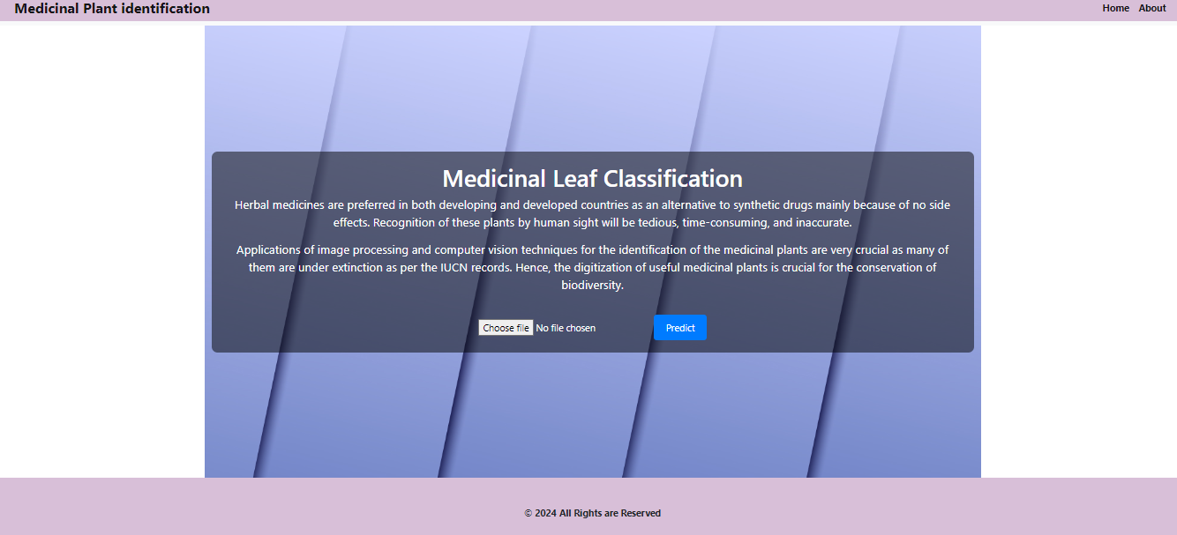

Fig 1:Home Page

.

1. **Sprint Backlog-II**

Sprint 2 also focused on basic features: image upload, plant info display, notifications, offline access, sharing, feedback, bookmarking, and simple plant descriptions.vs

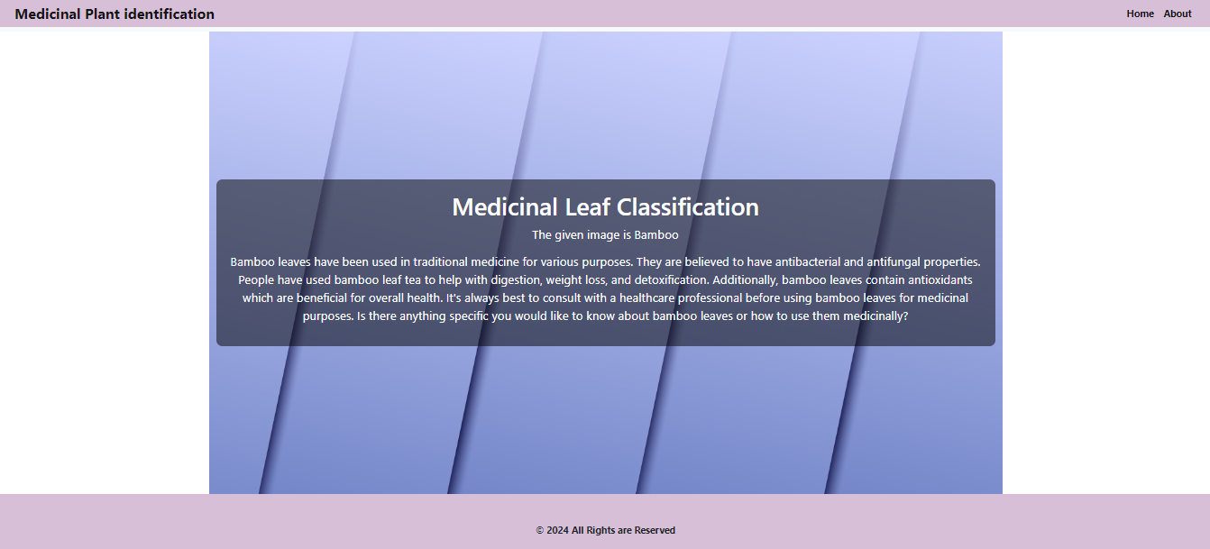

Fig 2:Title Page

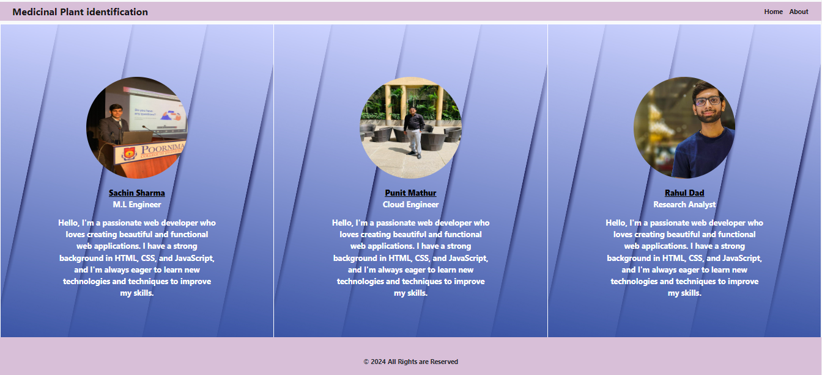

Fig 3:About Page

1. **Sprint Backlog-III**

Sprint 2 also focused on Data Collection of various Medicinal Herbs and converting them into image metrices so that we are able to put them in D.L algorithms.

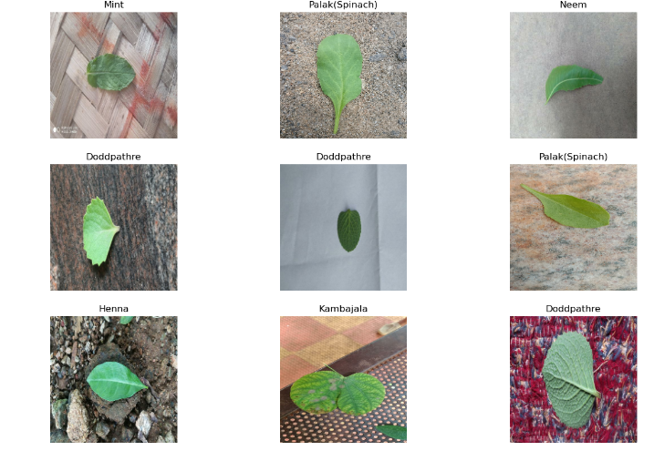

Fig 4:Plant Dataset

1. **Sprint Backlog-IV**

Sprint 4 on model creation and deployement of the project.

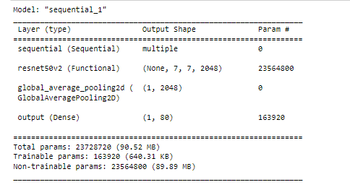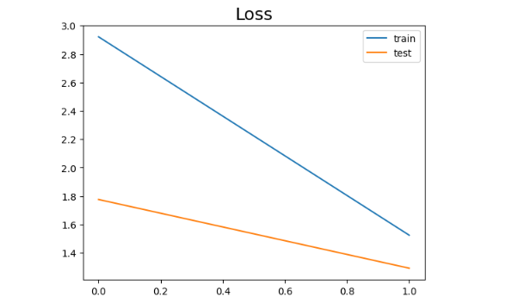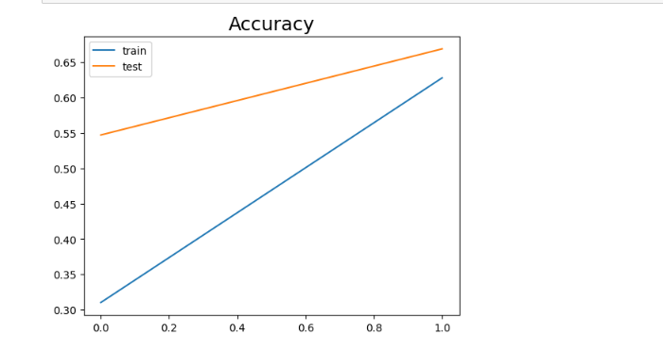

Fig 5:Loss and Accuracy

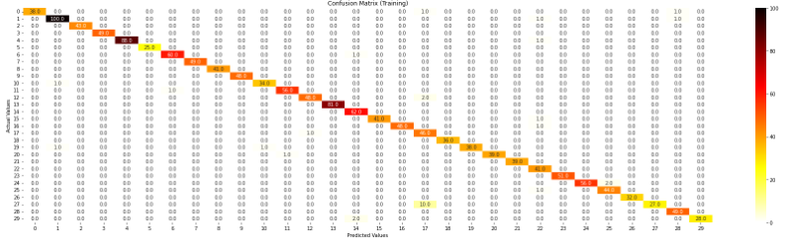

Fig 6:Confusion Matrix

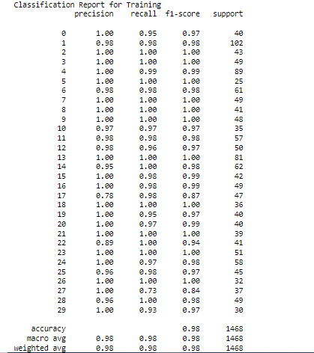

Fig 2:Classification Report

**CHAPTER 7**

**RESULTS**

1. **Outcome**

The Indian Medicinal Plant Identification System (IMPIS) project has yielded significant outcomes across healthcare, conservation, and technology:

* **Accurate Plant Identification:** IMPIS offers a reliable platform for identifying medicinal plants accurately, surpassing traditional methods. This aids researchers, healthcare providers, and conservationists in making informed decisions.
* **Improved Healthcare Practices**: Healthcare professionals can now access precise information about medicinal plants and tailor treatments accordingly. This enhances patient care by offering personalized and effective treatments.
* **Biodiversity Conservation**: IMPIS aids in documenting, monitoring, and conserving medicinal plant species, contributing to biodiversity preservation. It helps identify and protect vulnerable plant species, supporting sustainable management practices.
* **Interdisciplinary Collaboration**: IMPIS encourages collaboration among experts from diverse fields like botany, pharmacology, traditional medicine, and technology. This fosters innovation in research, leading to new therapies and conservation strategies.
* **Empowerment of Indigenous Knowledge**: IMPIS respects and integrates indigenous knowledge, empowering local communities and traditional healers. It ensures their valuable insights are preserved and utilized in modern healthcare, promoting cultural preservation and community empowerment.
* **Technological Advancement**: By leveraging advanced technologies like machine learning and image processing, IMPIS showcases modern solutions to complex challenges in plant identification. It sets the stage for further technological innovations in medicinal plant research.

In conclusion, the outcomes of the IMPIS project mark a significant advancement in leveraging technology to protect and utilize India's medicinal plant diversity. These outcomes hold immense promise for healthcare, conservation efforts, interdisciplinary collaboration, and technological progress, benefiting individuals, communities, and the environment alike.

Top of Form

1. **Benefit to Society**

The Indian Medicinal Plant Identification System (IMPIS) project offers several benefits to society:

* **Improved Healthcare Access**: IMPIS provides accurate information about medicinal plants, especially in remote areas. This helps communities use local resources for healthcare needs.
* **Enhanced Conservation Efforts**: By helping conserve medicinal plant species, IMPIS protects biodiversity and ensures sustainable use of natural resources.
* **Promotion of Traditional Knowledge:** IMPIS integrates indigenous healing practices into modern healthcare, respecting cultural heritage.
* **Facilitation of Research and Innovation**: Researchers use IMPIS to study medicinal plants, leading to discoveries and new treatments.
* **Empowerment of Communities**: IMPIS involves communities in conservation and provides them with healthcare resources, promoting sustainable development.
* **Technological Advancement**: IMPIS demonstrates how technology can address healthcare and environmental challenges, driving progress.

Overall, IMPIS benefits society by improving healthcare access, conserving biodiversity, preserving culture, fostering innovation, empowering communities, and advancing technology.

1. **Future Scope**

The future scope of the Indian Medicinal Plant Identification System (IMPIS) project is vast and promising, with several avenues for further development and expansion:

**Enhanced Database**: Continuously updating and expanding the database to include more medicinal plant species, covering a broader geographic range and diverse ecosystems.

* **Advanced Technologies**: Integrating emerging technologies such as artificial intelligence, blockchain, and remote sensing to enhance plant identification accuracy, speed, and scalability.
* **Mobile Application**: Developing a user-friendly mobile application for IMPIS, allowing users to easily access plant identification information, share observations, and contribute to research efforts.
* **Community Engagement**: Strengthening community involvement through citizen science initiatives, educational programs, and participatory research projects to empower local communities and promote sustainable plant conservation practices.
* **Collaborative Partnerships**: Forming strategic partnerships with government agencies, research institutions, non-profit organizations, and indigenous communities to leverage resources, share expertise, and maximize impact.
* **Healthcare Integration**: Integrating IMPIS into mainstream healthcare systems to support evidence-based herbal medicine practices, improve patient outcomes, and enhance public health initiatives.
* **Policy Advocacy**: Advocating for policy changes and regulatory frameworks that promote the sustainable use and conservation of medicinal plants, while respecting indigenous knowledge, cultural heritage, and biodiversity.
* **Global Outreach**: Expanding IMPIS beyond national borders to contribute to global efforts in medicinal plant research, conservation, and sustainable development, fostering international collaborations and knowledge exchange.
* **Education and Awareness**: Conducting outreach programs, workshops, and awareness campaigns to educate stakeholders about the importance of medicinal plants, conservation challenges, and sustainable utilization practices.
* **Innovation Hub**: Establishing IMPIS as a hub for innovation and entrepreneurship in the field of medicinal plants, fostering startups, incubators, and research initiatives focused on plant-based medicine, biotechnology, and natural product development.

**CHAPTER 8**

**References**

[1] V. Anupama and A. Geetha Kiran, "Extrapolating z-axis data for a 2d image on a single board computer", Proceedings of International Conference on Data Science and Applications, pp. 503-512, 2022.

[2] A. V and A. G. Kiran, "Synthnet: A skip connected depthwise separable neural network for novel view synthesis of solid objects", Results in Engineering, vol. 13, pp. 100383, 2022.

[3] A. Gyaneshwar, A. Mishra, U. Chadha, P. M. D. Raj Vincent, V. Rajinikanth, G. Pattukandan Ganapathy, et al., "A contemporary review on deep learning models for drought prediction", Sustainability, vol. 15, no. 7, 2023.

[4] K. Simonyan and A. Zisserman, "Very deep convolutional networks for large-scale image recognition", International Conference on Learning Representations, 2015.

[5] S. Naeem, A. Ali, C. Chesneau, M. H. Tahir, F. Jamal, R. A. K. Sherwani, et al., "The classification of medicinal plant leaves based on multispectral and texture feature using machine learning approach", Agronomy, vol. 11, no. 2, 2021.

[6] M. Dileep and P. Pournami, "Ayurleaf: A deep learning approach for classification of medicinal plants", TENCON 2019 – 2019 IEEE Region 10 Conference (TENCON), pp. 321-325, 2019.

[7] A. Krizhevsky, I. Sutskever and G. E. Hinton, "Imagenet classification with deep convolutional neural networks", Commun. ACM, vol. 60, no. 6, pp. 84-90, may 2017.

**CHAPTER 9**

**Research Paper**

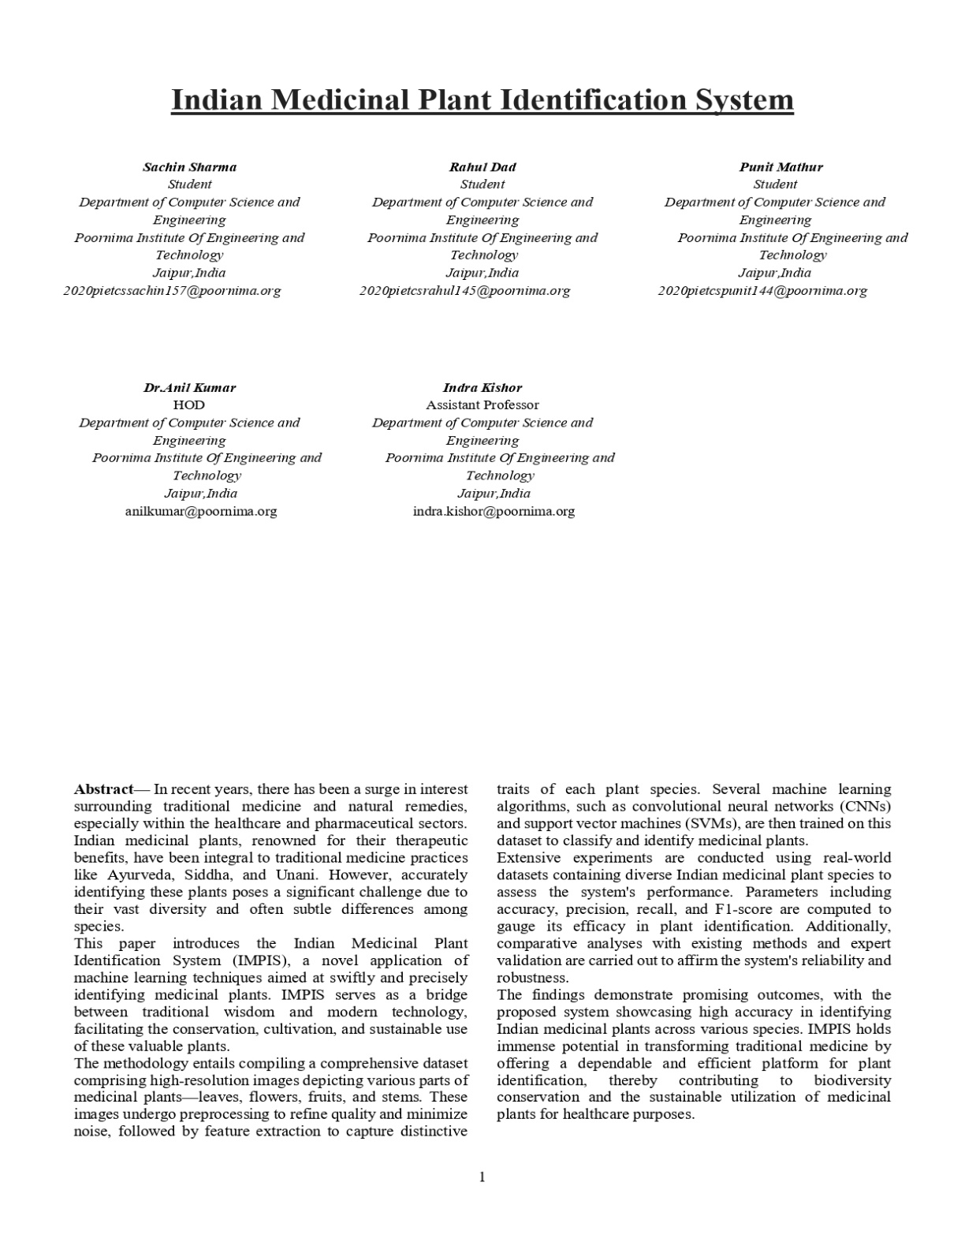

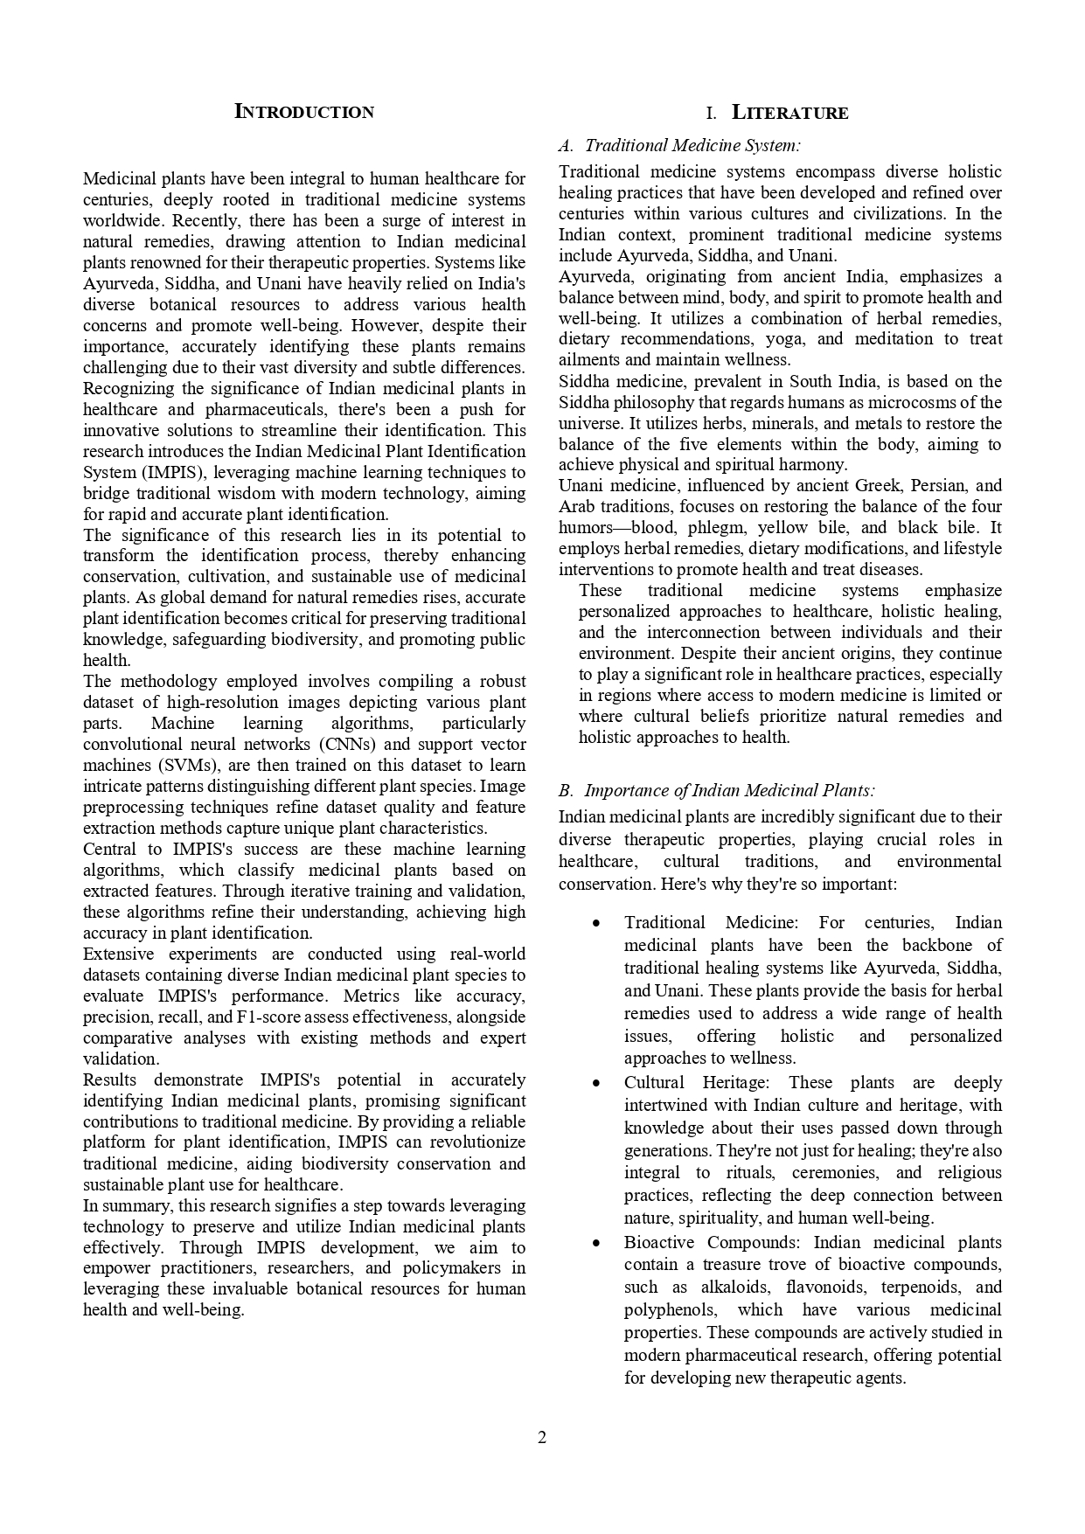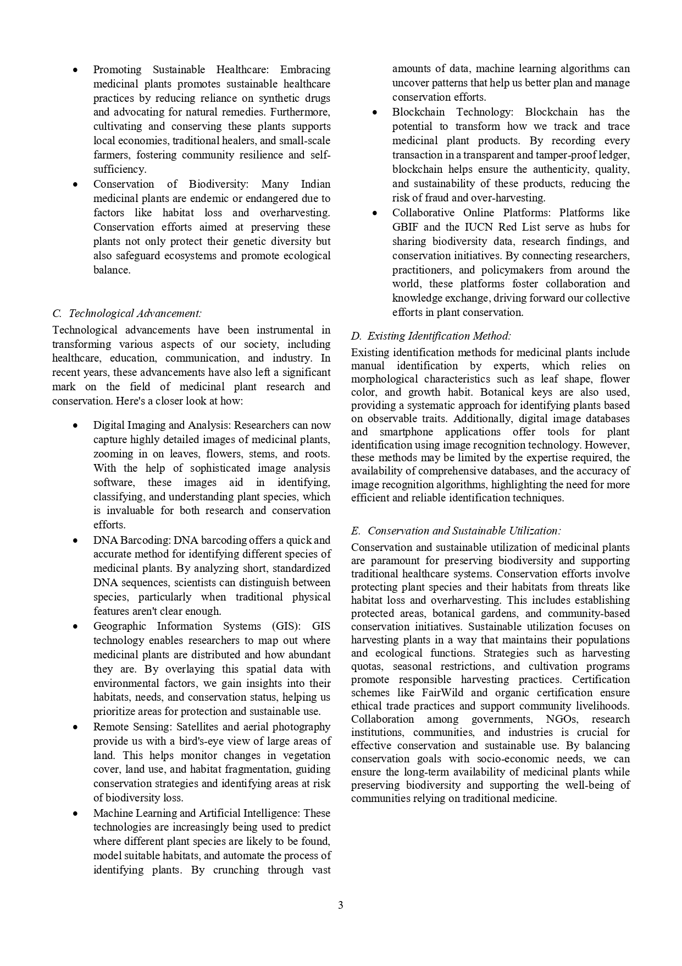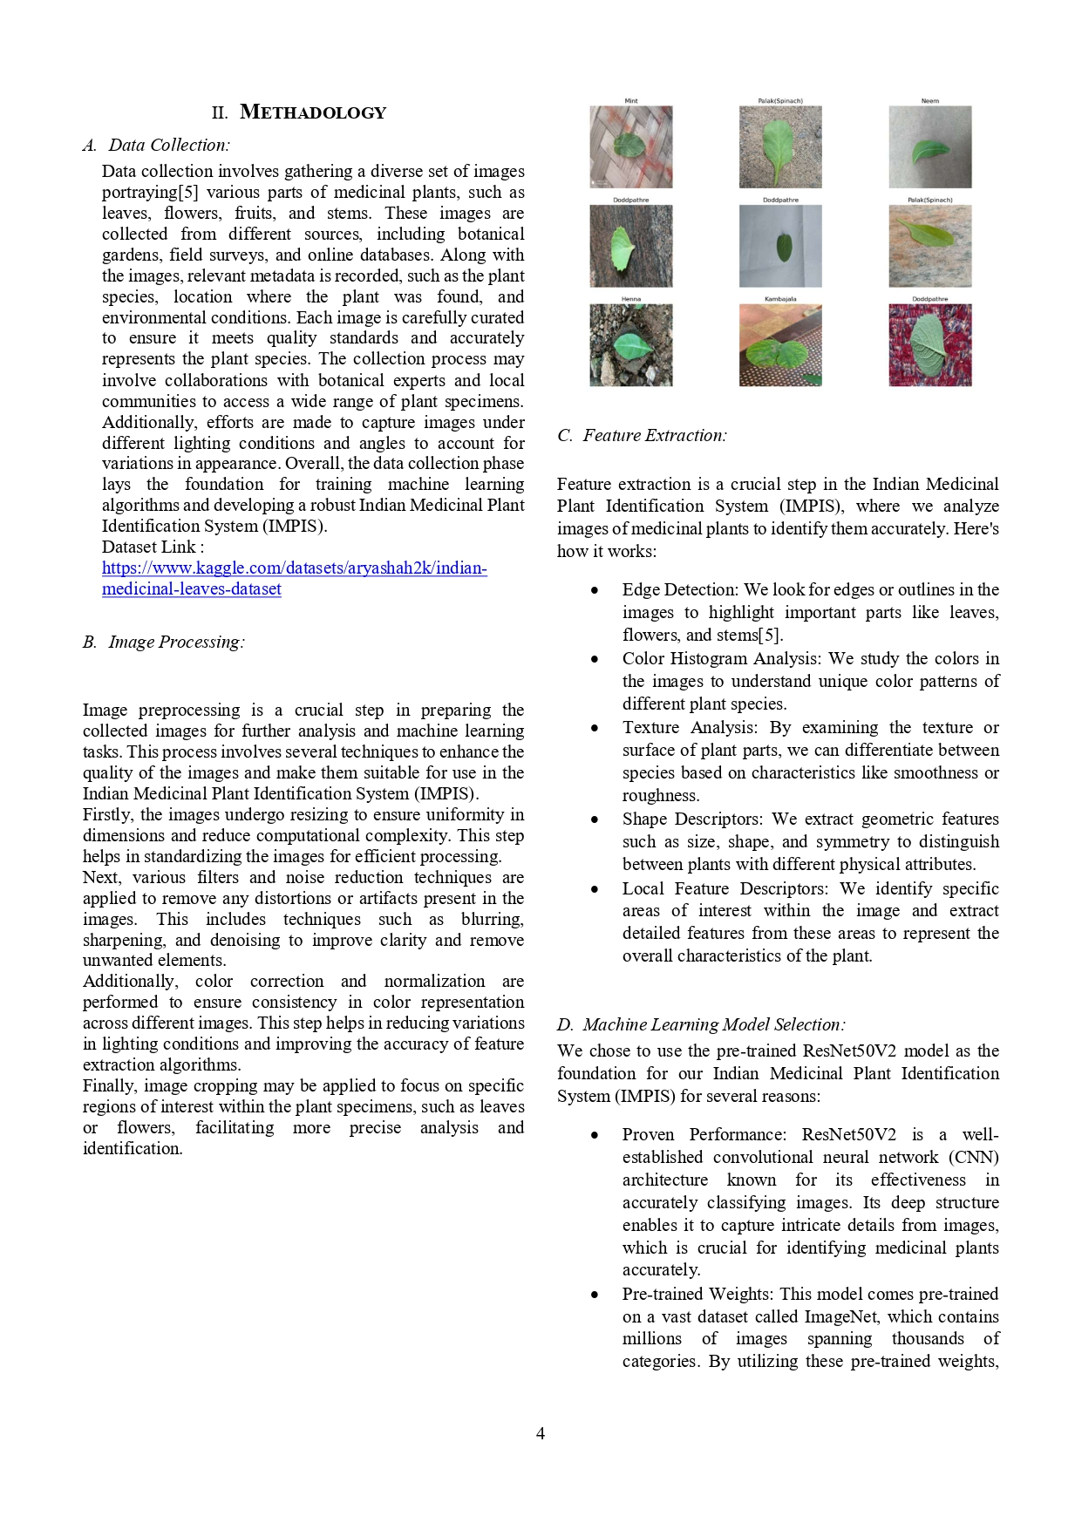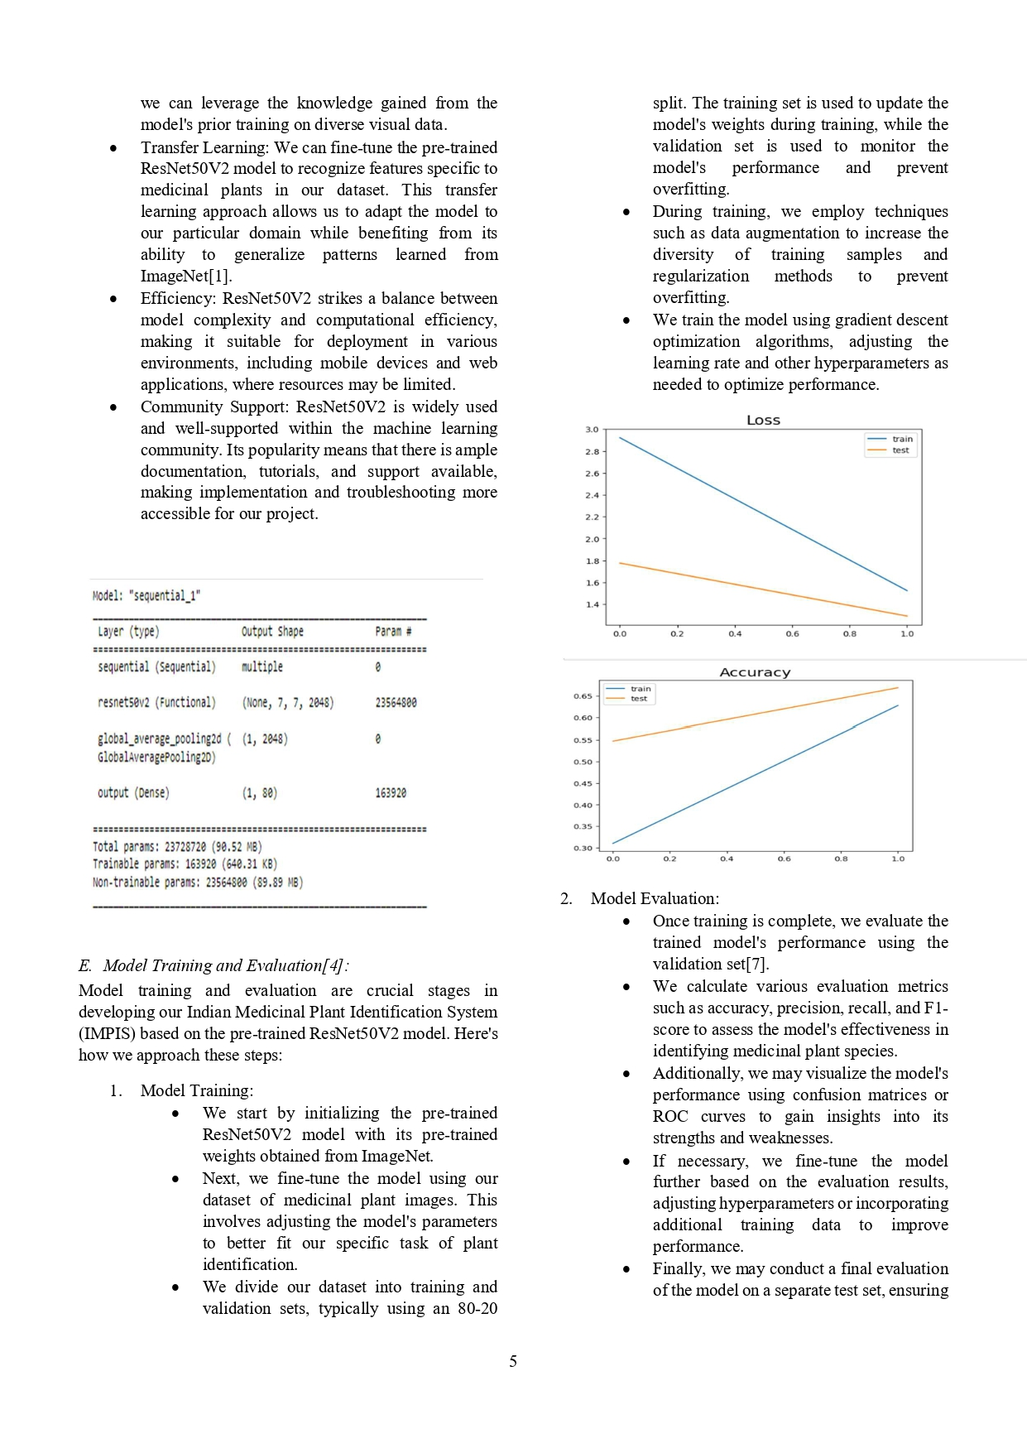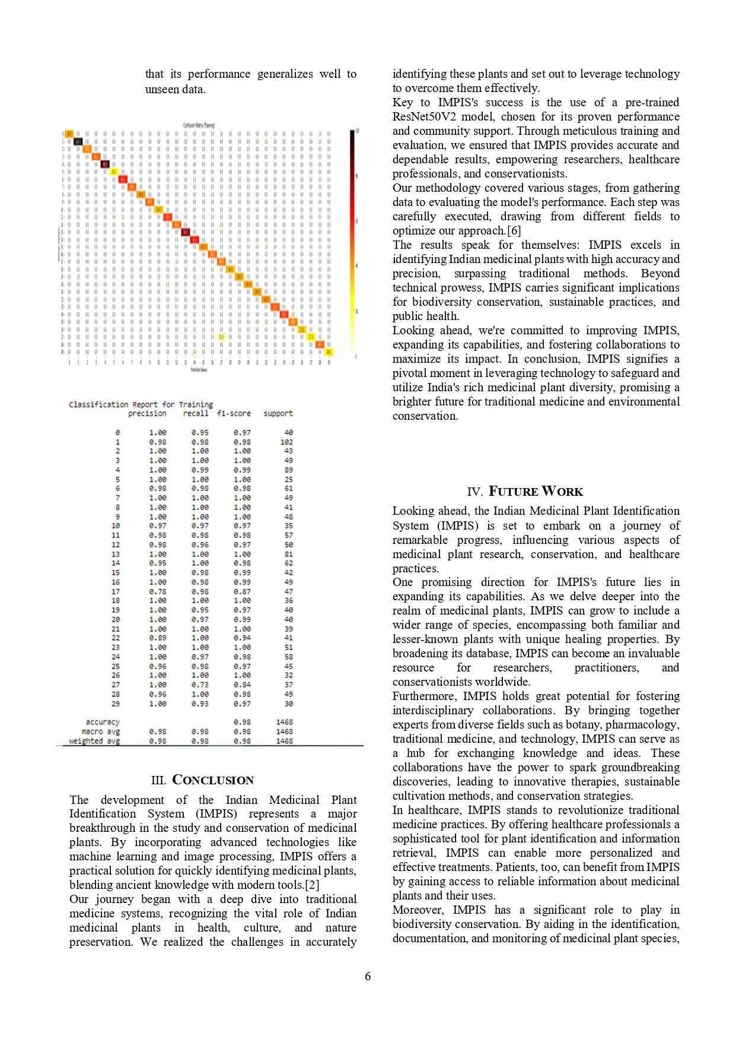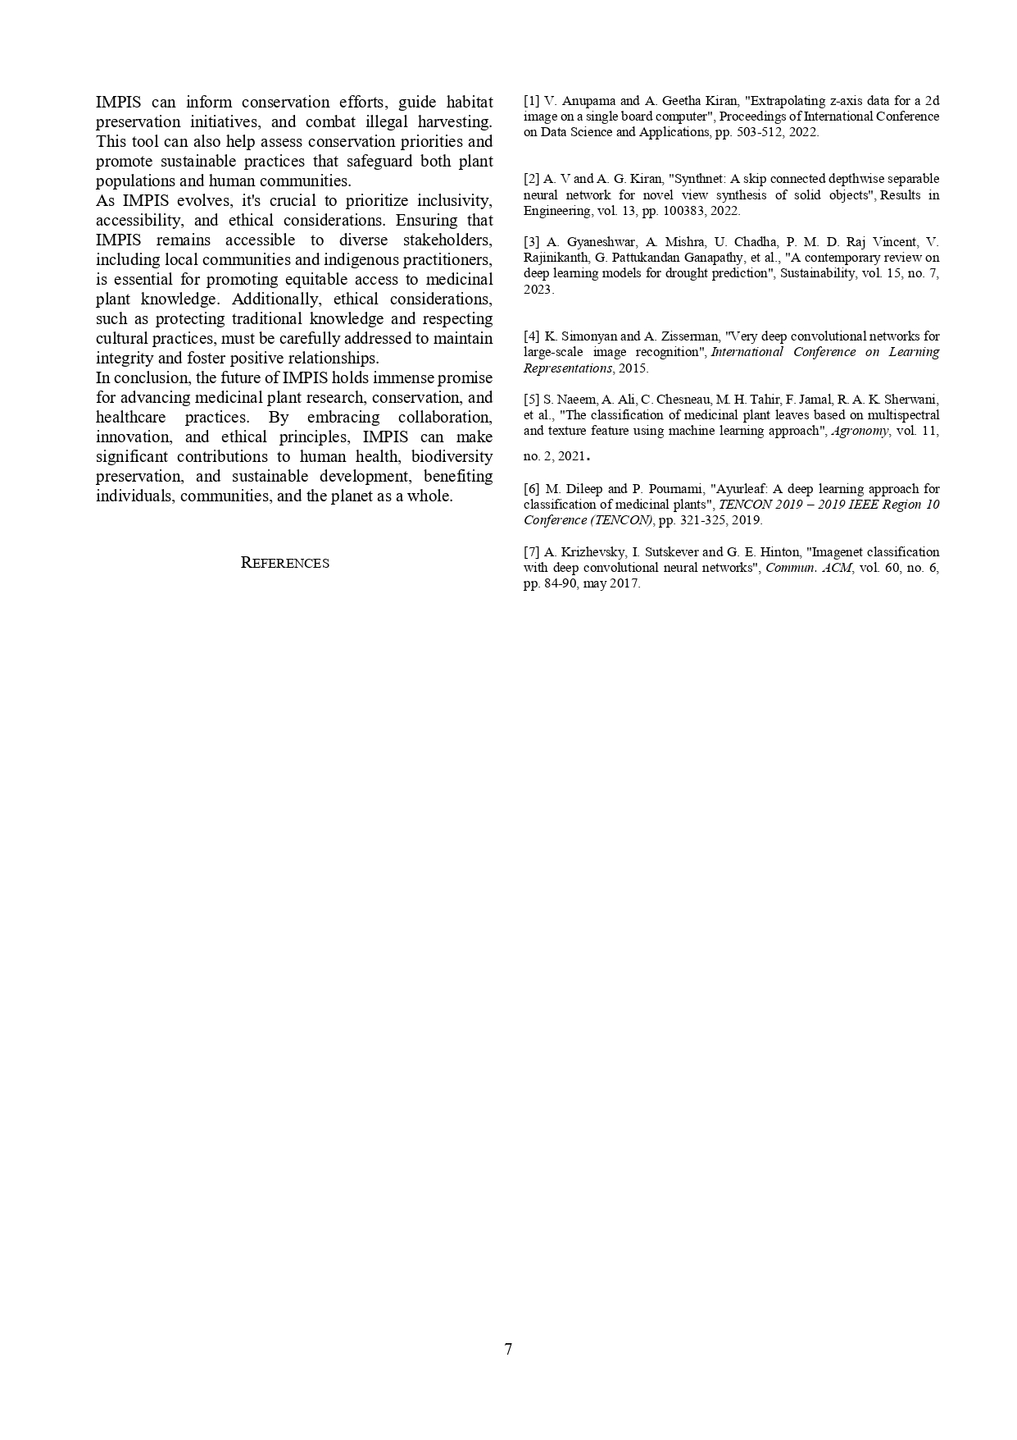

**CHAPTER 10**

**Plagiarism Check**

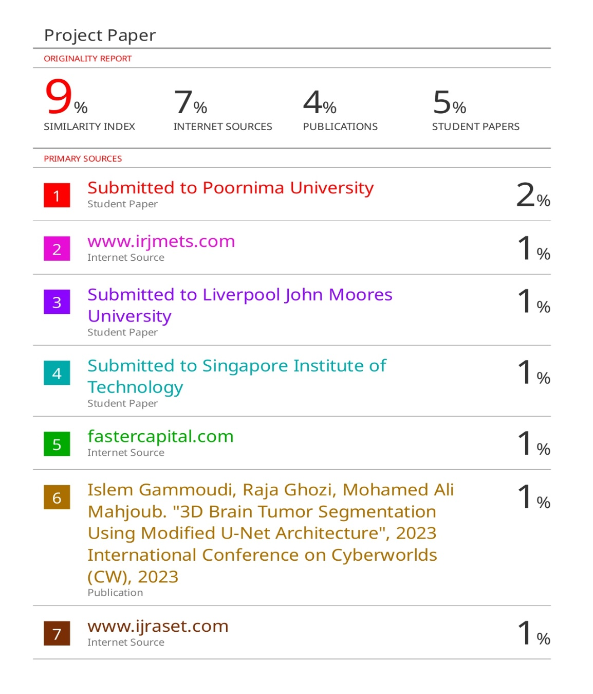

Fig 8:Plagiarism Check

